

CAPSTONE PROJECT REPORT
Report 6 – Software User Guides

– Hanoi, Jan 2025 –
Table of Contents
I. Record of Changes 5
II. Release Package & User Guides 6
1. Deliverable Package 6
2. Installation Guides 7
2.1 System Requirements 7
2.1.2 Hardware Requirements: 7
2.1.3 Network Requirements: 7
2.2 Installation Instruction 7
2.2.1 Environment and Tools Setup 7
2.2.1.1. Install Java JDK 21 7
2.2.1.2 Install Apache Maven 3.9.9 12
2.2.1.3. Install Visual Studio Code 14
2.2.1.4. Install IntelliJ IDEA 14
2.2.5. Install React.js version 18.2.0 15
2.2.2. Database Setup 15
2.2.3 Source Code Installation 20
2.2.3.1 Backend Setup 20
2.2.3.2 Frontend Setup 23
3. User Manual 24
3.1 Overview 24
3.2 Authentication 24
3.2.1 Log in 24
3.2.2 Forgot password 25
3.2.3 Change password 26
3.3 Category management 27
3.3.1 View category list 27
3.3.2 Create category 28
3.3.3 Update category 29
3.3.4 Delete category 30
3.4 Product management 31
3.4.1 Product list screen 31
3.4.2 Product details screen 32
3.4.3 Create product screen 32
3.4.4 Update product screen 34
3.4.5 Delete product screen 35
3.5 Order management 36
3.5.1 Order list screen 36
3.5.2 Create orders screen 37
3.5.3 Order details screen 38
3.6 Account management 38
3.6.1 Account list screen 38
3.6.3 Add new account screen 39
3.6.4 Edit account screen 40
3.6.5 Delete account screen 41
3.7 Role Management 42
3.7.1 Role list screen 42
3.7.2 Add new role screen 43
3.7.3 Edit role screen 44
3.7.4 Delete role screen 45
3.8 Supplier Management 46
3.8.1 Supplier list screen 46
3.8.2 Create supplier screen 48
3.8.4 Update supplier screen 48
3.8.5 Delete supplier screen 49
3.9 Customer Management 50
3.9.1 Customer list screen 50
3.9.2 Add new customer screen 51
3.9.3 Edit customer screen 52
3.10 Purchase order management 53
3.10.1 Purchase order list screen 53
3.10.2 Purchase order detail screen 55
3.10.3 Create purchase order screen 56
3.10.4 Update purchase order screen 57
3.11 Promotion Management 59
3.11.1 View promotion list 59
3.11.2 Add new promotion 60
3.11.4 Edit promotion 61
3.11.5 Delete promotion 62
3.12 Product price 63
3.12.1 Product price list screen 63
3.12.2 Edit product price screen 64
3.13 Report Management 65
3.13.1 Revenue Report 65
3.13.2 Product Report 67
3.13.3 Customer Report 69
3.13.4 Supplier Report 71
3.14 Workshift management 72
3.14.1 Workshift list screen 72
3.14.2 Workshift detail screen 74
3.14.3 Open workshift screen 76
3.14.4 Close workshift screen 78

I. Record of Changes
Date | A*  M, D | In charge | Change Description
30/11/2025 | A | HuyNX | Added 1. Deliverable Package
30/11/2025 | A | NamNV | Added 2. Installation Guides
1/12/2025 | A | DuongNT17 | Added 3.2 Authentication
1/12/2025 | A | DuongNT17 | Added 3.3 Category Management
1/12/2025 | A | DuongNT17 | Added 3.4 Product Management
2/12/2025 | A | DuongNT18 | Added 3.5 Account Management
2/12/2025 | A | DuongNT18 | Added 3.6 Role & Permission Management
2/12/2025 | A | DuongNT18 | Added 3.7 Supplier Management
3/12/2025 | A | NamNV | Added 3.8 Customer Management
3/12/2025 | A | NamNV | Added 3.9 Purchase Order Management
3/12/2025 | A | NamNV | Added 3.10 Promotion Management
4/12/2025 | A | HuyNX | Added 3.11 Product Price Management
4/12/2025 | A | HuyNX | Added 3.12 Report Management
4/12/2025 | A | HuyNX | Added 3.13 WorkShift Management
*A - Added M - Modified D - Deleted

II. Release Package & User Guides

1. Deliverable Package

No. | Deliverable Item | Sub-Items | Type | Version
Code Package
1 | Source Code (BE) | SSMS_BE | .zip | 1.0.0
2 | Source Code (FE) | SSMS_FE | .zip | 1.0.0
Database
3 | Database Script(s) | SSMS_Database | .sql | 1.0.0
Document
4 | Final Report Document | Report7_Final Project Report | .docx | 1.0.0
5 | Project Introduction | Report1_Project Introduction | .docx | 1.0.0
6 | Project Management Plan | Report2_Project Management Plan | .docx | 1.0.0
7 | Software Requirement Specification | Report3_Software Requirement Specification | .docx | 1.0.0
8 | Software Design Document | Report4_Software Design Document | .docx | 1.0.0
Testing
9 | Testing Document | Report5_Test Document | .docx | 1.0.0
10 | Unit test | Report5_Unit Test | .xlxs | 1.0.0
11 | Integration test | Report5_Integration Test | .xlxs | 1.0.0
12 | System test | Report5_System Test | .xlxs | 1.0.0
Slide
13 | Slide Presentation | SEP490_G127_Slide | .pptx | 1.0.0

2. Installation Guides

2.1 System Requirements
- Operating System: Windows 10 or higher as the development or hosting environment.
- Install JDK 21 as it is necessary for running the Java/SpringBoot backend
- SpringBoot The backend is developed using SpringBoot version 3.3.3. Required dependencies will be managed using Maven or Gradle, which are defined in the project configuration files (pom.xml or build.gradle).
- IntelliJ IDEA Community is recommended for Java/SpringBoot backend development.
- The frontend is built using Next.js version 14.2.11. Ensure Node.js and npm are installed, as they are prerequisites for Next.js
- React.js version 18.2.0 is required to run the Next.js frontend.
- SQL Server 2022 (Version 16.0) serves as the relational database for data storage

2.1.2 Hardware Requirements:
● Processor: Quad-core or higher recommended for development, Dual-core minimum for server.
● RAM: 8 GB minimum for development, 4GB minimum for server.
● Storage: At least 20 GB of free space for development.

2.1.3 Network Requirements:
- Operating System: Recommended Windows 8.1, macOS, Ubuntu 20.04 LTS or equivalent/above.
- CPU: Intel Core i3 or equivalent/above.
- RAM: Minimum 4GB, recommended 8GB or more
- Internet: Internet connection with download and upload speeds of at least 5 Mbps.
- Web Browsers: Recommended Chrome (v65 or higher), Firefox (v60 or higher), Edge (v79 or higher) and Opera (v52 or higher).

2.2 Installation Instruction

2.2.1 Environment and Tools Setup

2.2.1.1. Install Java JDK 21
1. Download JDK 21 from Oracle official website
- Link download: Link download

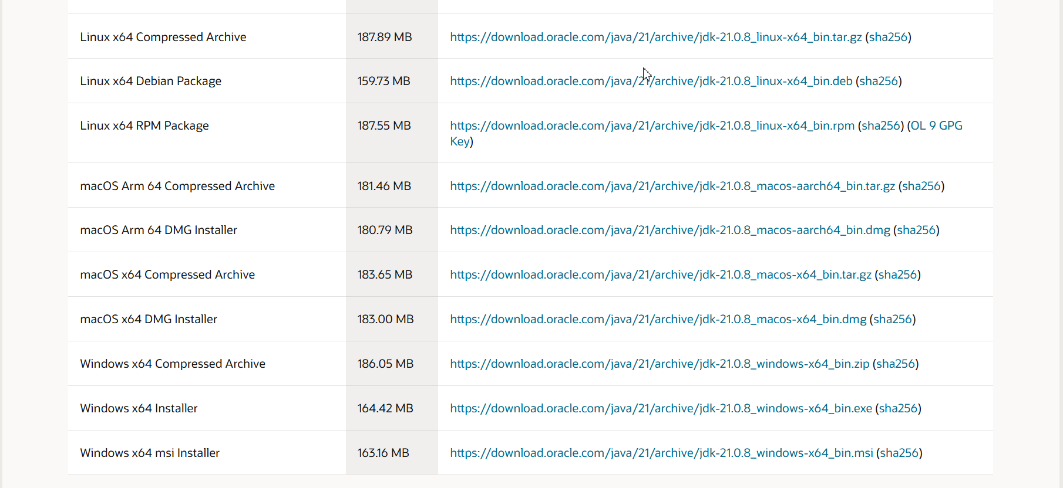

Figure 2.1: Install Java JDK 21 - 1
- Extract
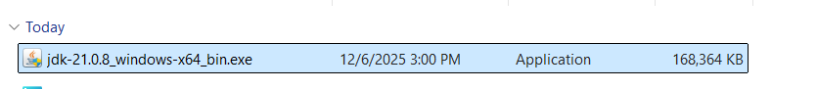
Figure 2.2: Install Java JDK 21 - 2
- Install and remember the installation path, for example: C:\Program Files\Java\jdk-21
2. Add environment variable
- Open Edit the system environment variables → Environment Variables
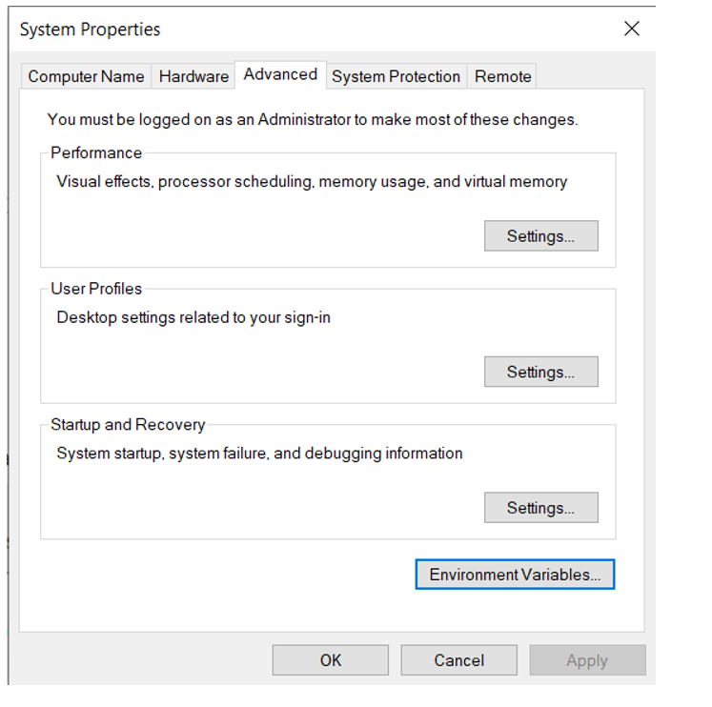
Figure 2.3: Install Java JDK 21 - 3

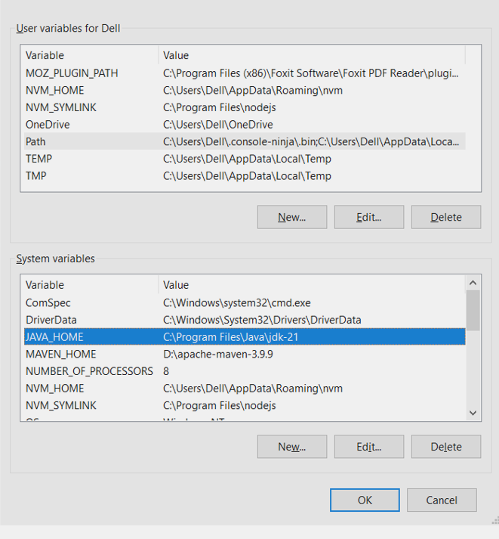
Figure 2.4: Install Java JDK 21 - 4
- Create new variable in System variables
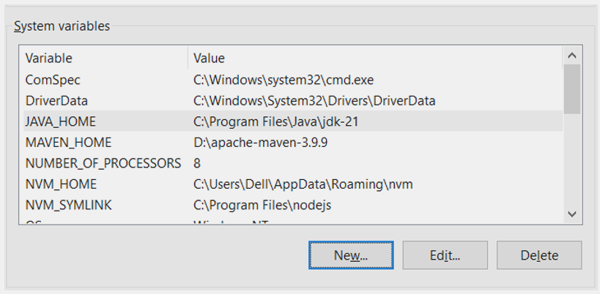
Figure 2.5: Install Java JDK 21 - 5
- Enter value

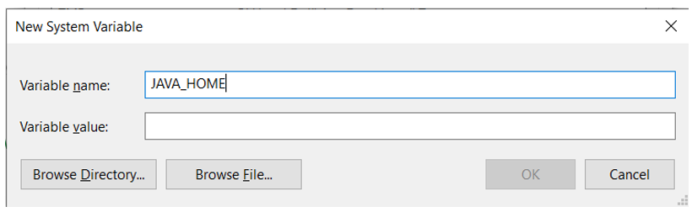

Figure 2.6: Install Java JDK 21 - 6
- Click Browse Directory to add the path to the JAVA_HOME value
- Select the extracted path in step 1: C:\Program Files\Java\jdk-21

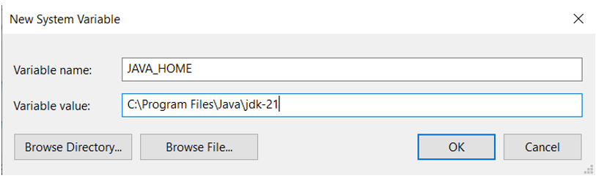

Figure 2.7: Install Java JDK 21 - 7
● Scroll to Path, then click Edit

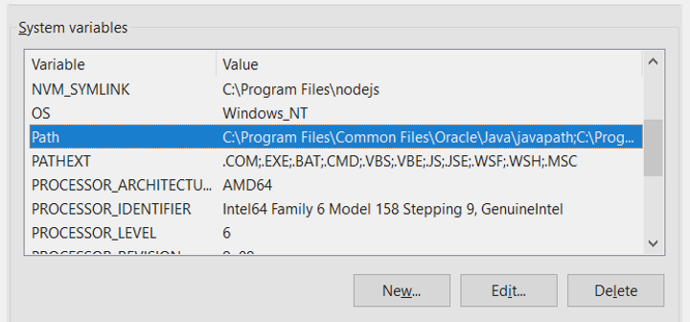
Figure 2.8: Install Java JDK 21 - 8
- In Path, click New to add: %JAVA_HOME%\bin
- Then click OK one by one to save
- Test:
  - Open powershell
  - java -version
- Expected result:
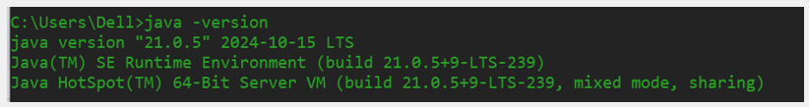

Figure 2.9: Install Java JDK 21 - 9

2.2.1.2 Install Apache Maven 3.9.9
1. Download Apache Maven 3.9.9: Link download

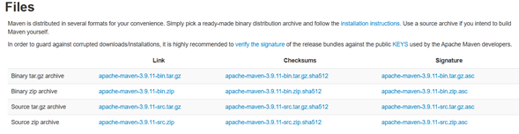
Figure 2.10: Install Apache Maven 3.9.9 - 1
- Extract to folder, for example: D:\apache-maven-3.9.9

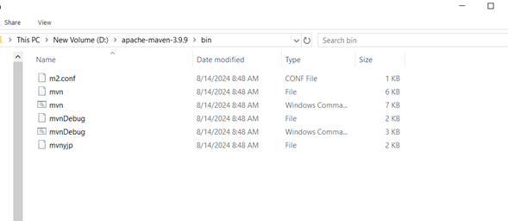
Figure 2.11: Install Apache Maven 3.9.9 - 2
2. Continue to do the steps to add environment variables like installing jdk
3. Add environment variables:
- MAVEN_HOME = D:\apache-maven-3.9.9
- In Path, add: %MAVEN_HOME%\bin
4. Check:
- mvn -v

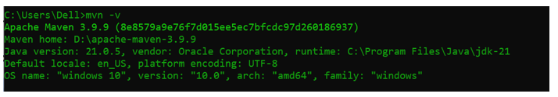
Figure 2.12: Install Apache Maven 3.9.9 - 3

2.2.1.3. Install Visual Studio Code
1. Download Visual Studio Code:
- Go to the official website: Download Visual Studio Code - Mac, Linux, Windows
- Click Download for Windows (or choose your operating system: macOS, Linux).
2. Install Visual Studio Code:
- After downloading the installer file, double-click to run it.
- Select the following options:
  - Add to PATH (recommended, so you can open VSCode from the Command Line).
  - Register Code as an editor for supported file types.
- Complete the installation and launch VSCode.
3. Install Essential Extensions:
- Open VSCode and go to the Extensions tab (the square icon on the left sidebar or press Ctrl + Shift + X).
- Search for and install:
- ESLint
- Prettier - Code formatter
- Node.js Extension Pack
- GitLens

2.2.1.4. Install IntelliJ IDEA
1. Download IntelliJ IDEA:
- Go to the IntelliJ IDEA here.
- Download the appropriate installer for your operating system.
2. Install IntelliJ IDEA:
- Run the installer.
- Follow the installation instructions provided by the installer.

2.2.5. Install React.js version 18.2.0
1. Download React.js version 18.2.0
- Visit: https://legacy.reactjs.org/versions/
- Find version 18.2.0 for your operating system (Windows Installer .msi or .pkg for macOS).
2. Install React.js
- Run the downloaded installer file.
- Keep the default options (recommended to ensure npm is installed along with Node.js).
- Finish the installation.

2.2.2. Database Setup
Step 1: Access the link: https://www.microsoft.com/en-us/sql-server/sql-server-downloads

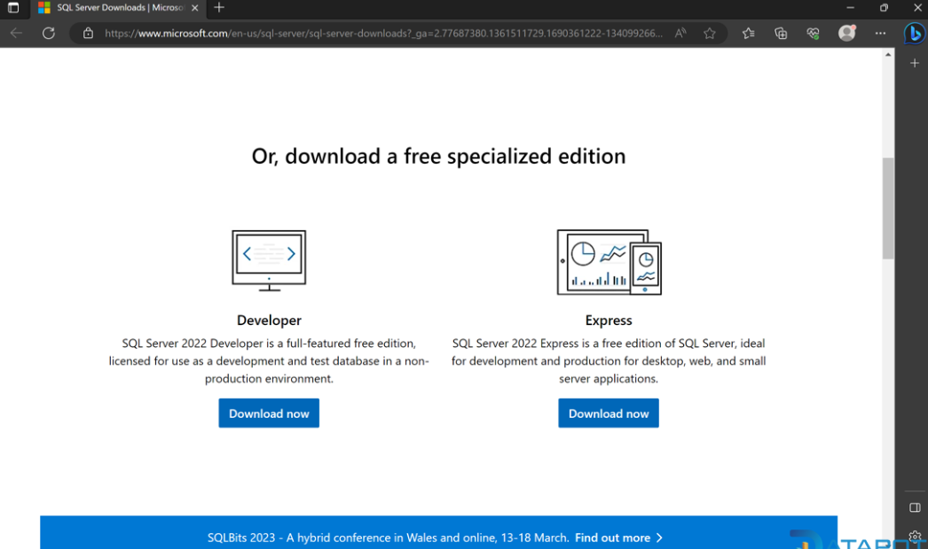
Figure 2.13: Install and Configure SQL Server 1
Step 2: Go to Express edition of SQL Server 2022 and select Download now, select Open file.
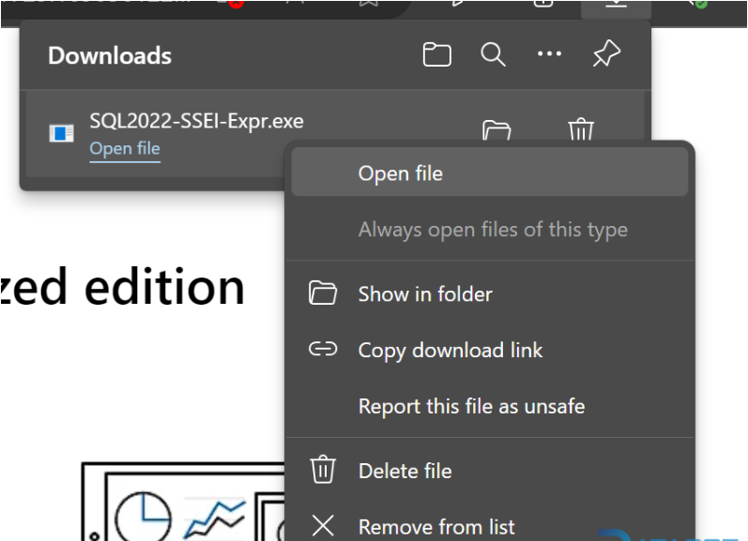
Figure 2.14: Install and Configure SQL Server 2

Step 3: Select Basic -> Accept -> Select Browser storage -> Install.
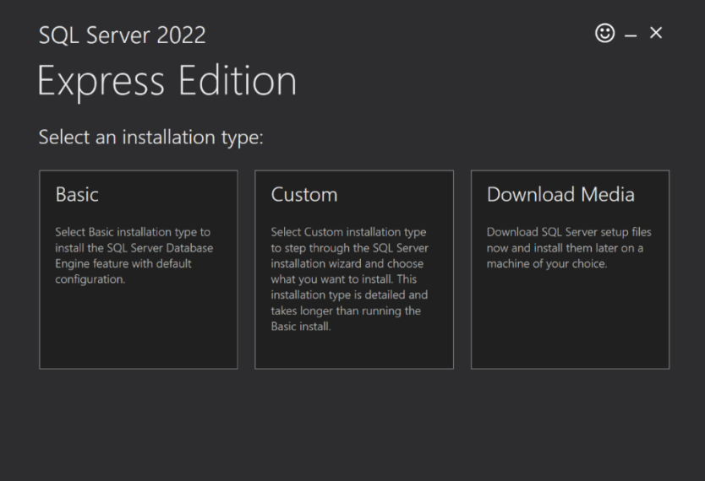

Figure 2.15: Install and Configure SQL Server 3
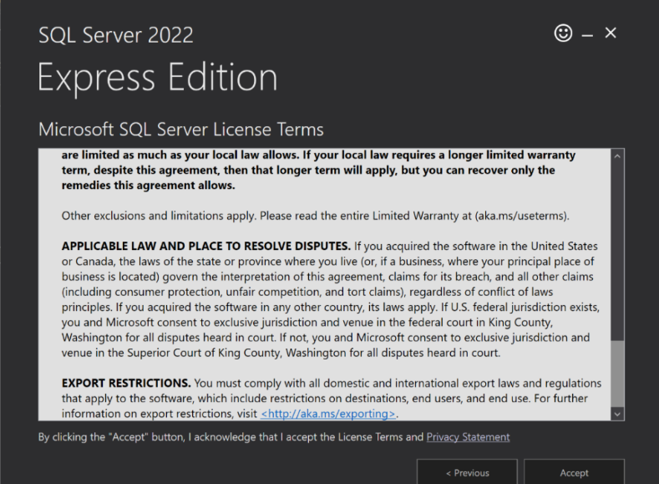

Figure 2.16: Install and Configure SQL Server 4
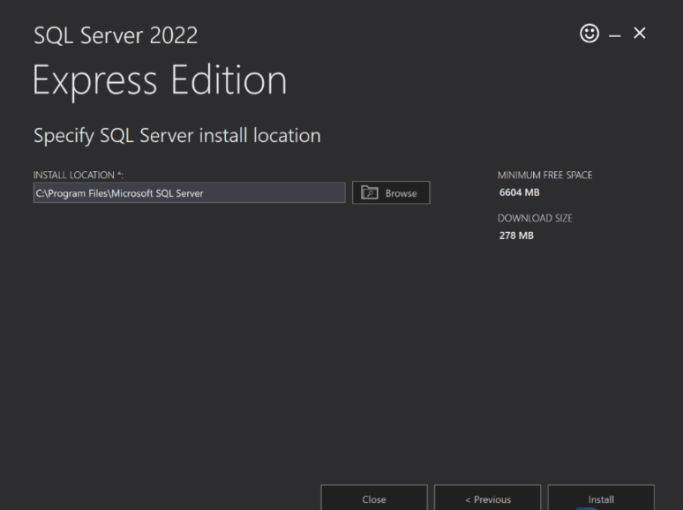
Figure 2.17: Install and Configure SQL Server 5
Step 4: After downloading successfully, click Install SSMS.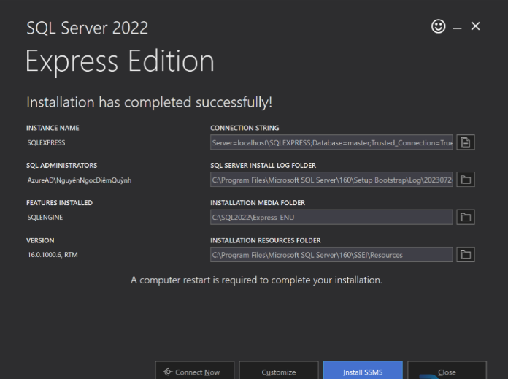
Figure 2.18: Install and Configure SQL Server 6
Step 5: After the Download SSMS window appears, click on the Download SSMS link.

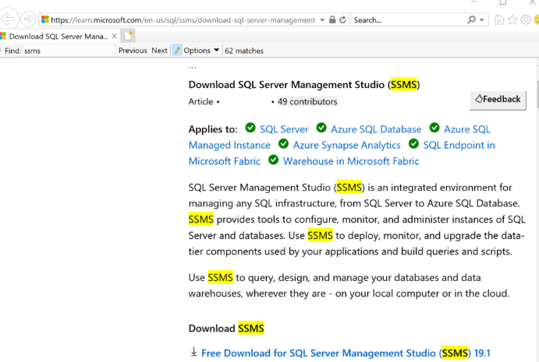
Figure 2.19: Install and Configure SQL Server 7
Step 6: After downloading successfully, click Install.
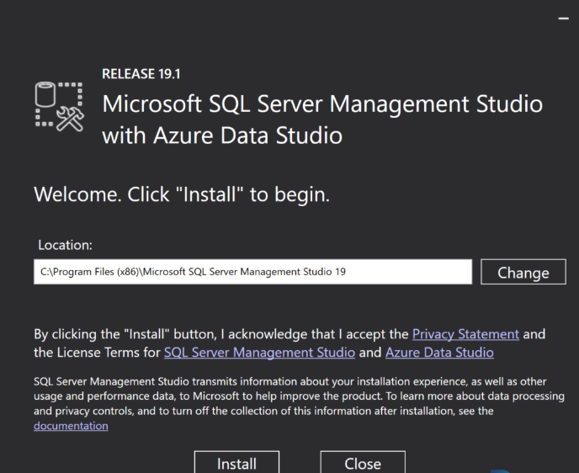
Figure 2.20: Install and Configure SQL Server 8
Step 7: After installation, open Microsoft SQL Server Management Studio 19, select Connect.

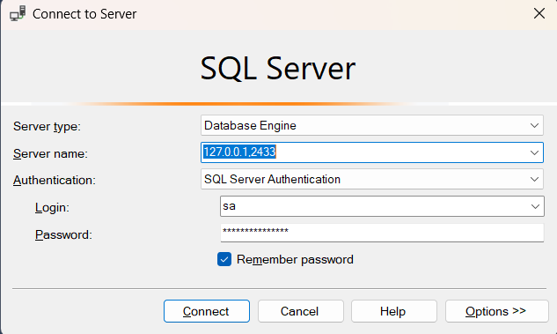
Figure 2.21: Install and Configure SQL Server 9

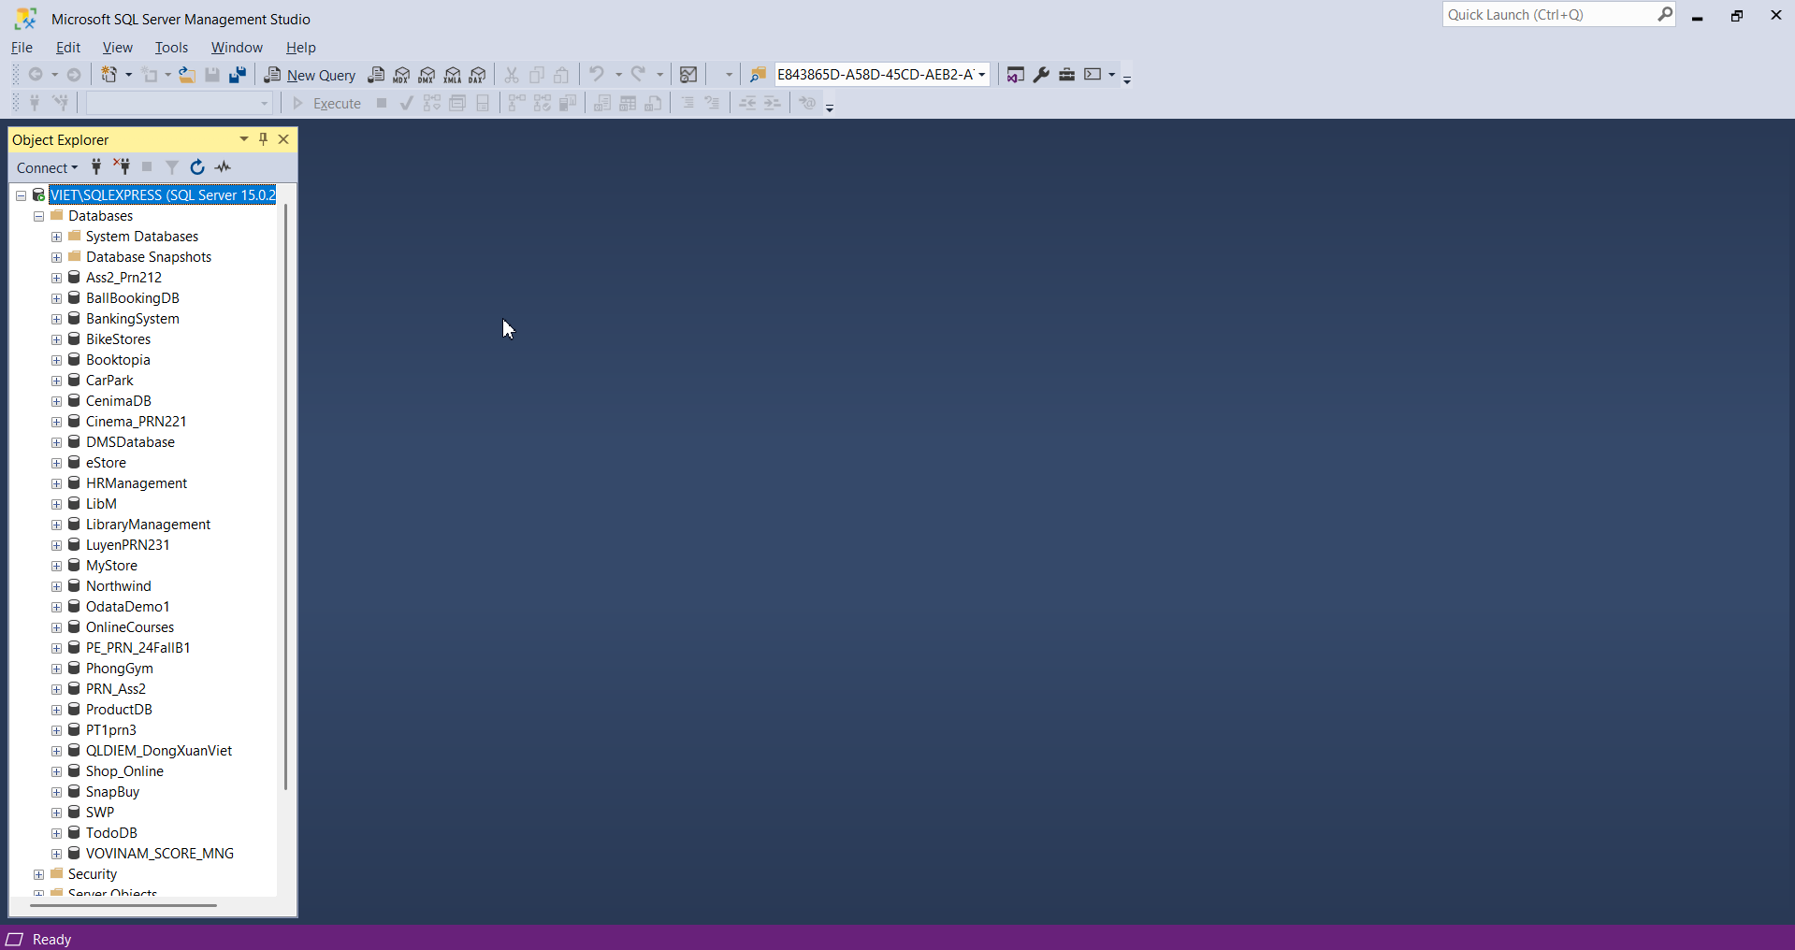
Figure 2.22: Install and Configure SQL Server 10

2.2.3 Source Code Installation

2.2.3.1 Backend Setup
- Install GitHub Desktop
+ Download git in, GitHub Desktop


Figure 2.23:Install GitHub Desktop
- Clone the Repository
- Open GitHub Desktop and sign in to your GitHub account.
- Locate the repository for the Backend source code.
- Click File > Clone Repository, then select the repository from the list or paste the repository URL.
- Choose a directory on your machine where the repository will be saved and click Clone.

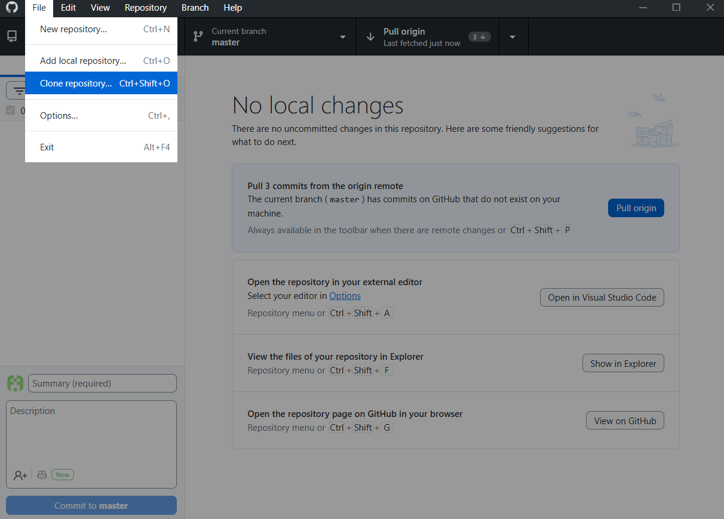
Figure 2.24: GitHub Desktop 1
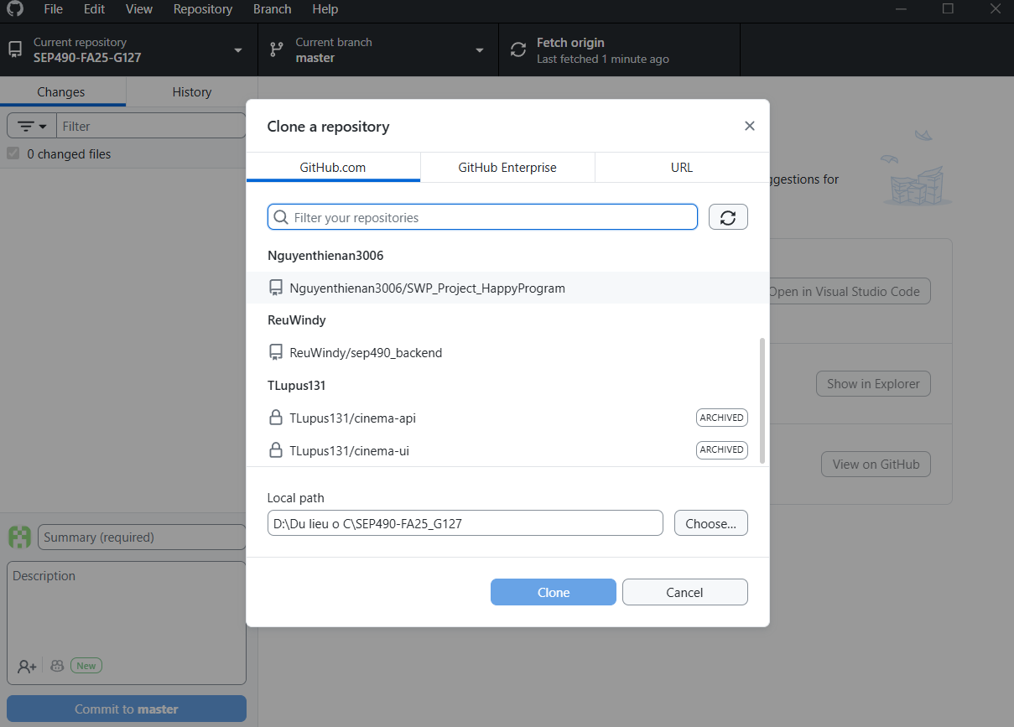

Figure 2.25: GitHub Desktop 2
- Open source code with IntelliJ IDEA Community Edition :
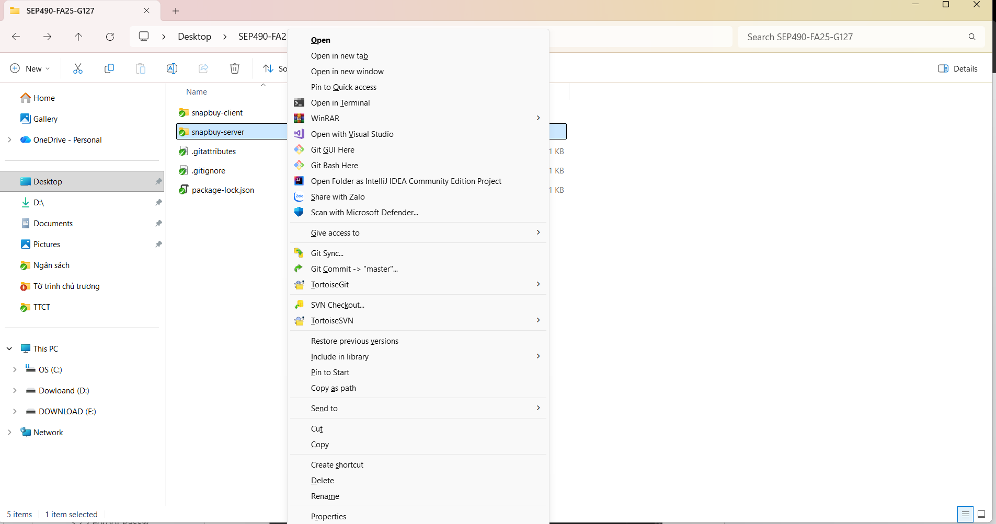
Figure 2.26: Open source code
- Build and Run project:

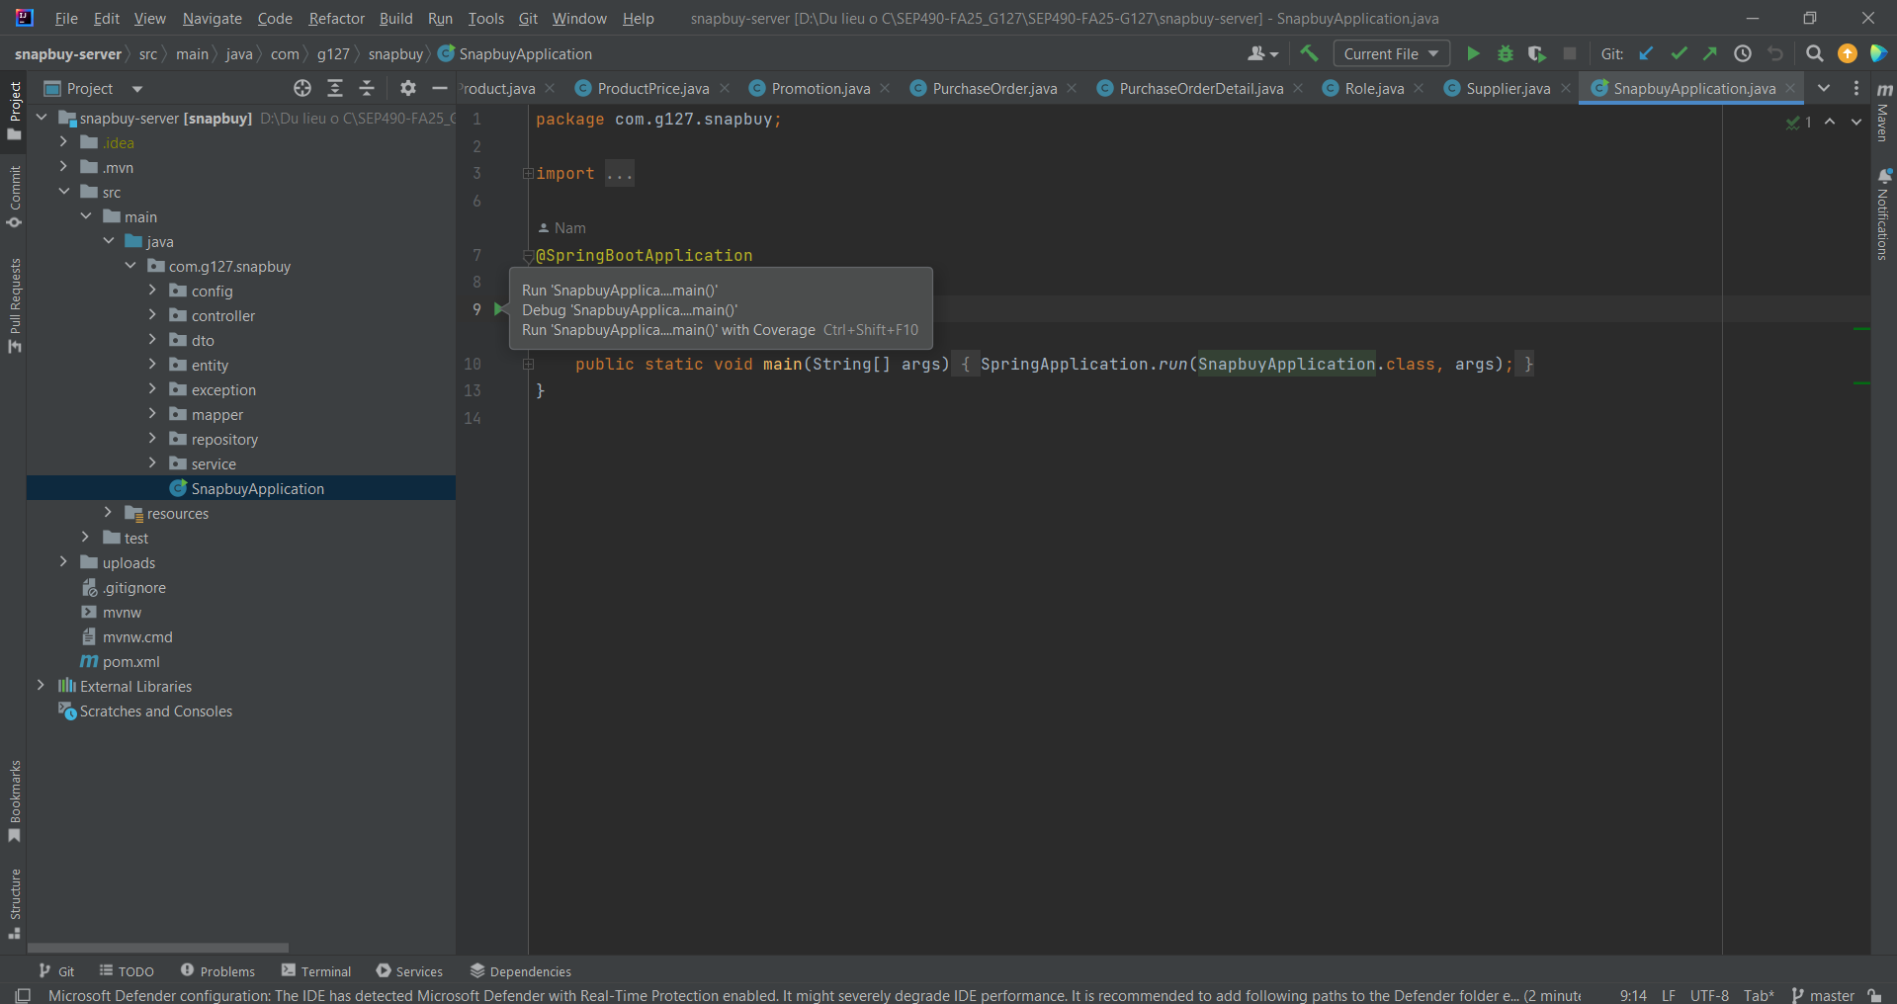

2.2.3.2 Frontend Setup
- In terminal, type cd my-app and npm i
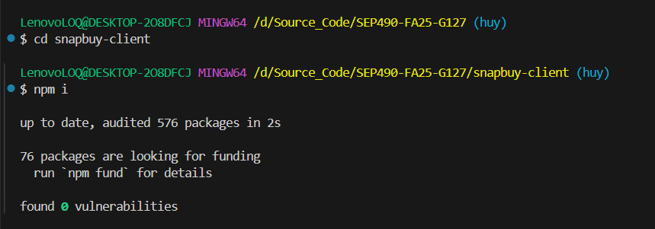
- Finish, type npm run dev to run project
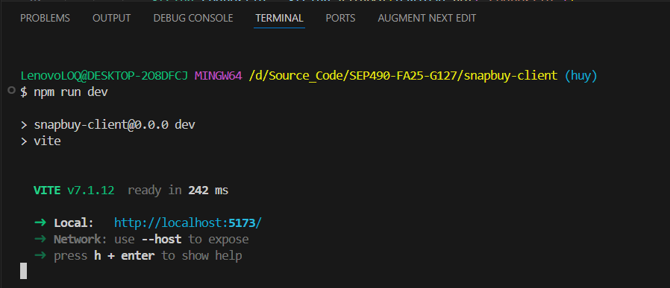
- Client run:
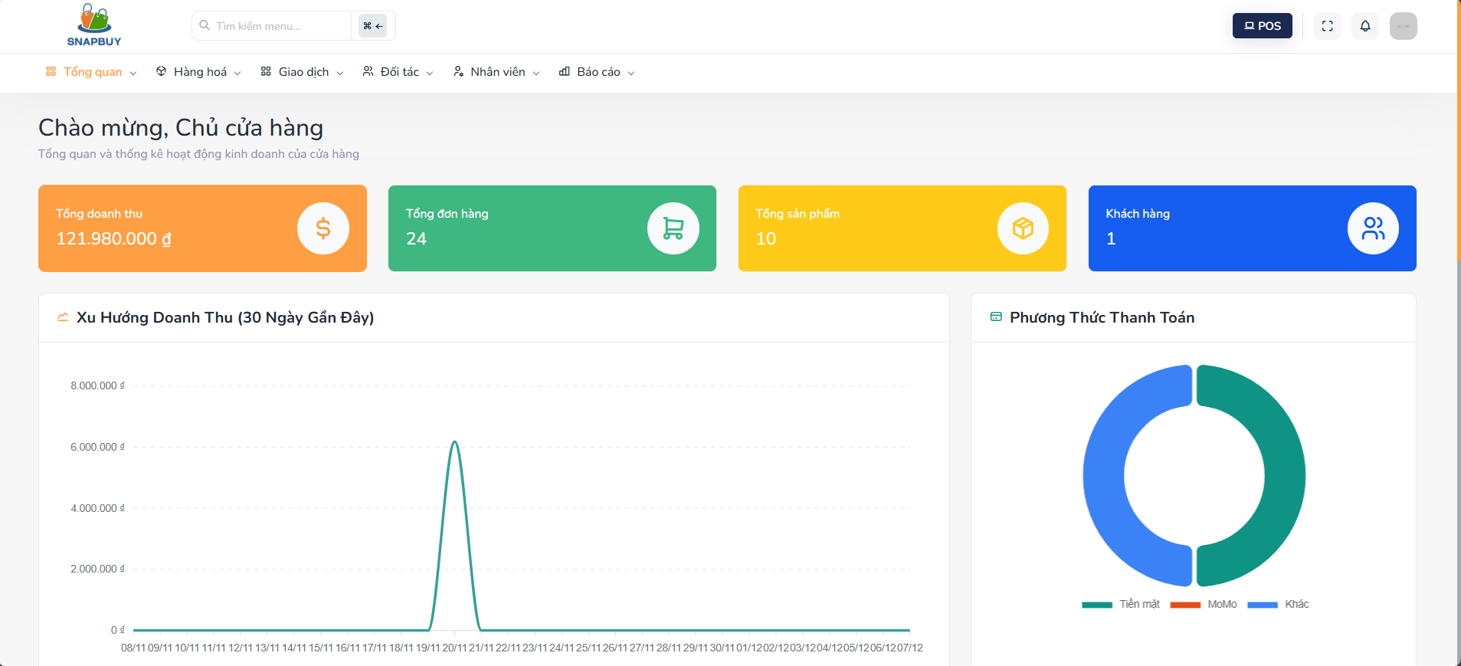

3. User Manual

3.1 Overview
- SnapBuy System is a comprehensive retail management application designed to streamline and automate daily store operations. It provides an all-in-one solution for managing products, categories, orders, suppliers, customers, promotions, pricing, reports, and employee workshifts. The system is built to enhance workflow efficiency, minimize manual errors, and deliver actionable business insights through an intuitive interface and a powerful backend infrastructure.

3.2 Authentication

3.2.1 Log in
- Description: The user wants to log in to the system to access functions according to their role.

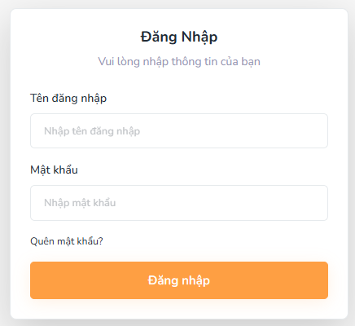
Figure 3.2.1. Log in
Step 1: At the “Login” screen, input Tên đăng nhập (email address) and Mật khẩu (password).
- Tên đăng nhập: must be in a valid email format (e.g., user@example.com).
- Mật khẩu: masked input, required field.
Step 2: Click the “Đăng Nhập” button.
- If the entered credentials are correct, the system authenticates the user and moves to the “Homepage” screen.
- If the user forgot their password, they can click “Quên Mật Khẩu” to navigate to the Forgot Password screen.

3.2.2 Forgot password
- Description: User wants to recover their password when they forget it, using the system’s email-based password reset process.
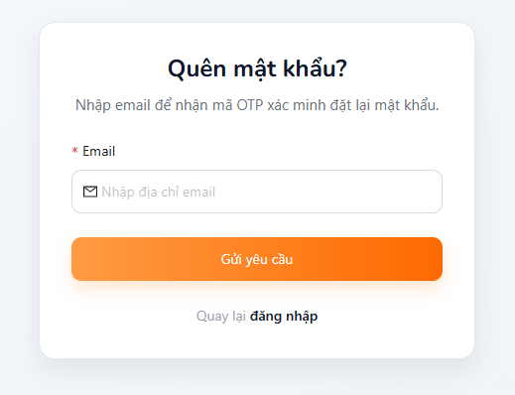
Figure 3.2.2. Forgot password
Step 1: At the “Forgot Password” screen, input your Email.
- The email must follow the correct format (e.g., user@example.com).
- This field is required.
Step 2:Click the “Gửi yêu cầu” button to send a password reset request.
- The button is only enabled when the entered email exists in the system and matches a valid user account.
Step 3:The system will send a password recovery email to the provided address with instructions to reset the password.
Step 4: To return to the login page, click “Quay lại đăng nhập”.

3.2.3 Change password
- Description: User wants to change the password of their system login account to ensure security during system access.

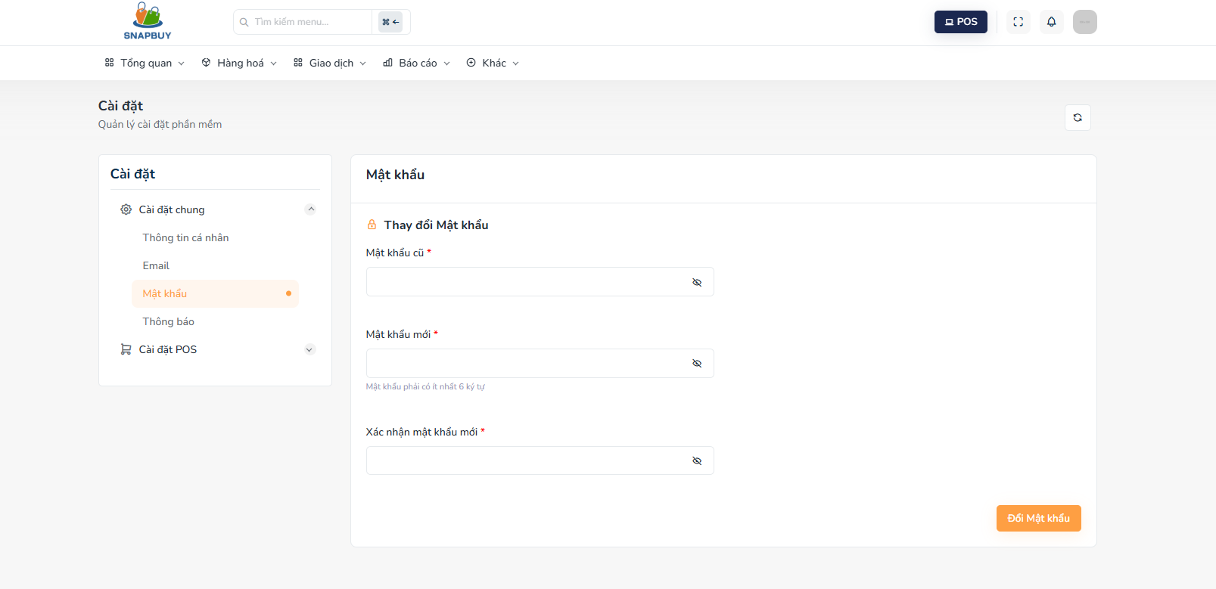
Figure 3.2.3. Change Password
Step 1:At the “Change Password” screen, enter the required information:
- Mật khẩu cũ: enter your current password (masked, required).
- Mật khẩu mới: enter a new password that meets security criteria:
- At least 1 uppercase letter,
- At least 1 lowercase letter,
- At least 1 digit,
- At least 1 special character.
Step 2:Xác nhận mật khẩu mới: re-enter the new password.
- Must match the Mật khẩu mới field (masked, required).
Step 3:Click the “Đổi mật khẩu” button to submit and update your password.
Step 4:If all fields are valid and the old password is correct, the system will update the password successfully

3.3 Category management

3.3.1 View category list
- Description: Admin wants to view and manage the list of categories, including creating, searching, editing, and deleting category records.
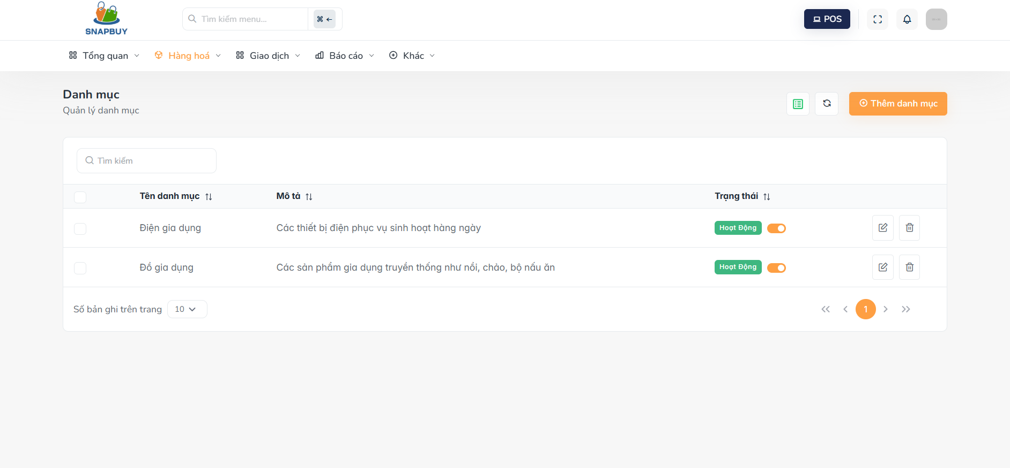
Figure 3.3.1. View Category List
Step 1: Admin click on “Hàng hóa” then click “ Danh mục”
Step 2:When accessing the “View Category List” screen, the system displays all existing categories with the following fields:
- Tên danh mục: Category name (String, required).
- Mô tả: Category description (String, required).
- Trạng thái: Category status (Boolean: true/false).
Step 3: Admin can search category
- Use the search bar to enter a keyword related to the category name.
- The list updates to display only the matching categories.

3.3.2 Create category
- Description: Admin wants to add a new product category into the system, ensuring that the category name and description are correctly recorded.
Step 1: Click the “Thêm danh mục” button and the system navigates the Admin to the Create Category screen.

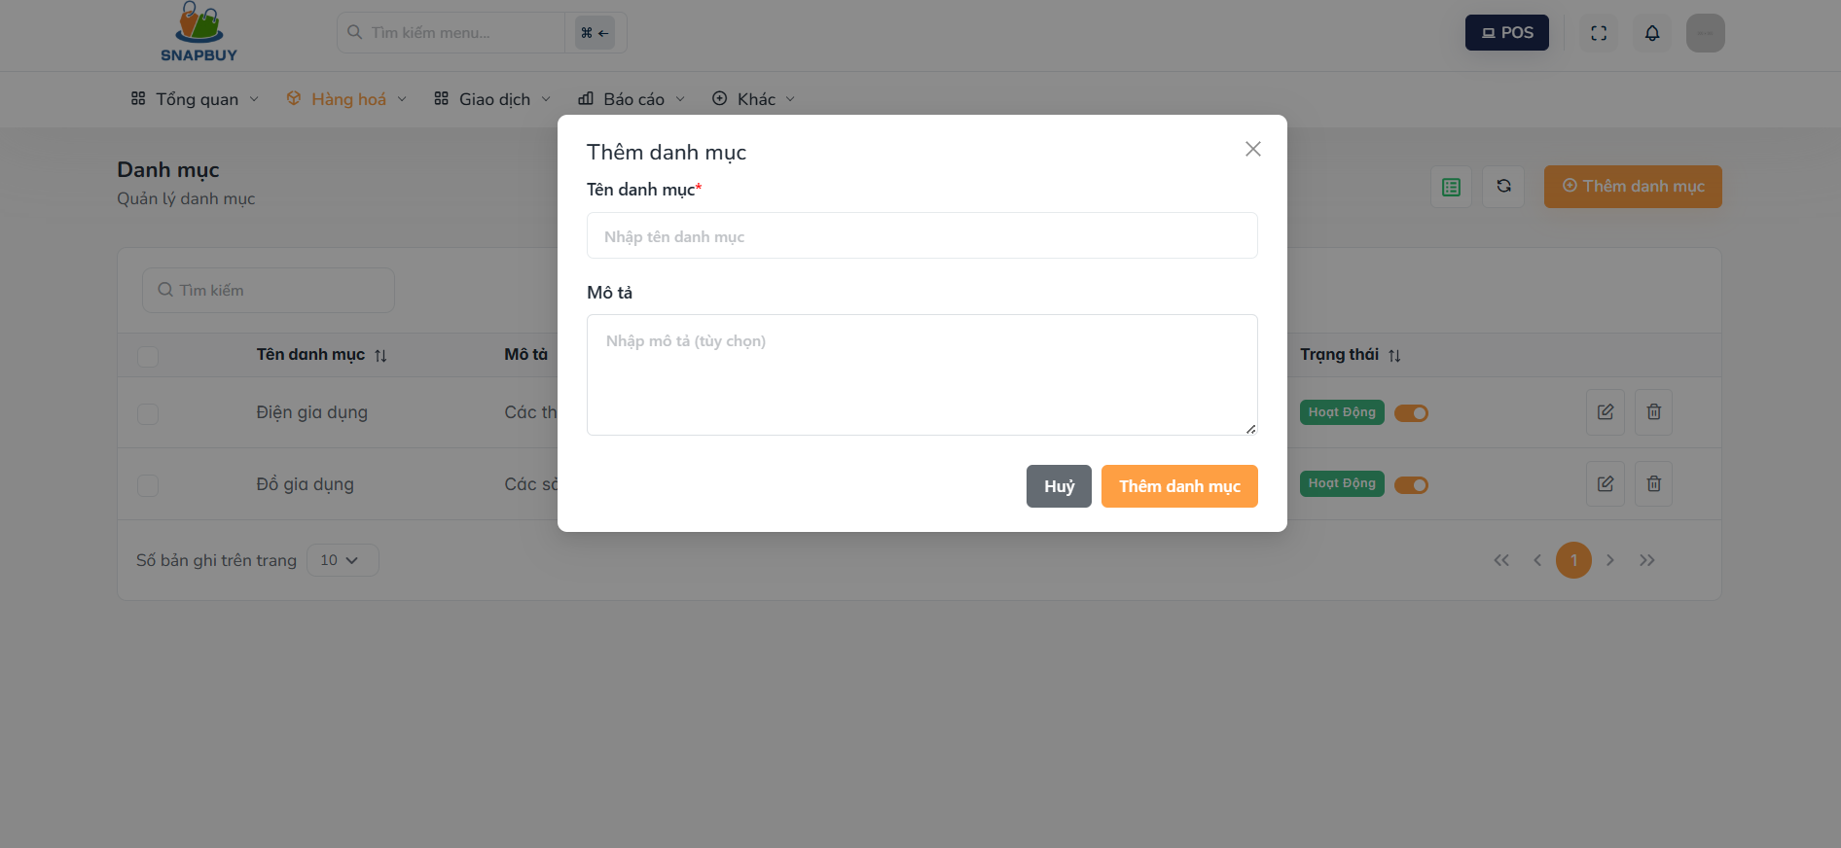
Figure 3.3.2. Create Category
Step 2:At the “Create Category” screen, enter the required information:
- Tên danh mục:Input the name of the new category (Text).
- Mô tả:Enter a description for the category (Text).
Step 3: After completing the fields, click “Thêm danh mục” to save the new category.
- The system will create the category and add it to the category list.
Step 4:If the Admin does not want to proceed, click “Hủy”.
- The form will close, and no information will be saved.

3.3.3 Update category
- Description: Admin wants to update the details of an existing product category, including the category name and description, ensuring that the system always reflects the most accurate and up-to-date information.
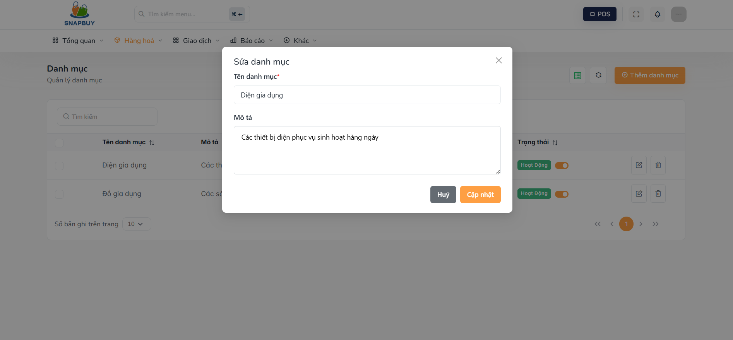
Figure 3.3.3. Update Category
Step 1 : At the “Update Category” screen, the system displays the current information of the selected category:
- Tên danh mục: existing category name (Text).
- Mô tả: existing category description (Text).
Step 2 :Modify the fields as needed:
- Tên danh mục: update the name of the category.
- Mô tả: adjust or rewrite the category description.
Step 3 :After making the necessary changes, click the “Cập nhật” button.
Step 4 :The system saves the updated category information and returns to the Category List screen.
If the Admin decides not to proceed, click “Hủy”.The form closes without saving any changes.

3.3.4 Delete category
- Description:Admin wants to delete an existing product category from the system, ensuring that the category is permanently removed and will no longer be available for product assignment.

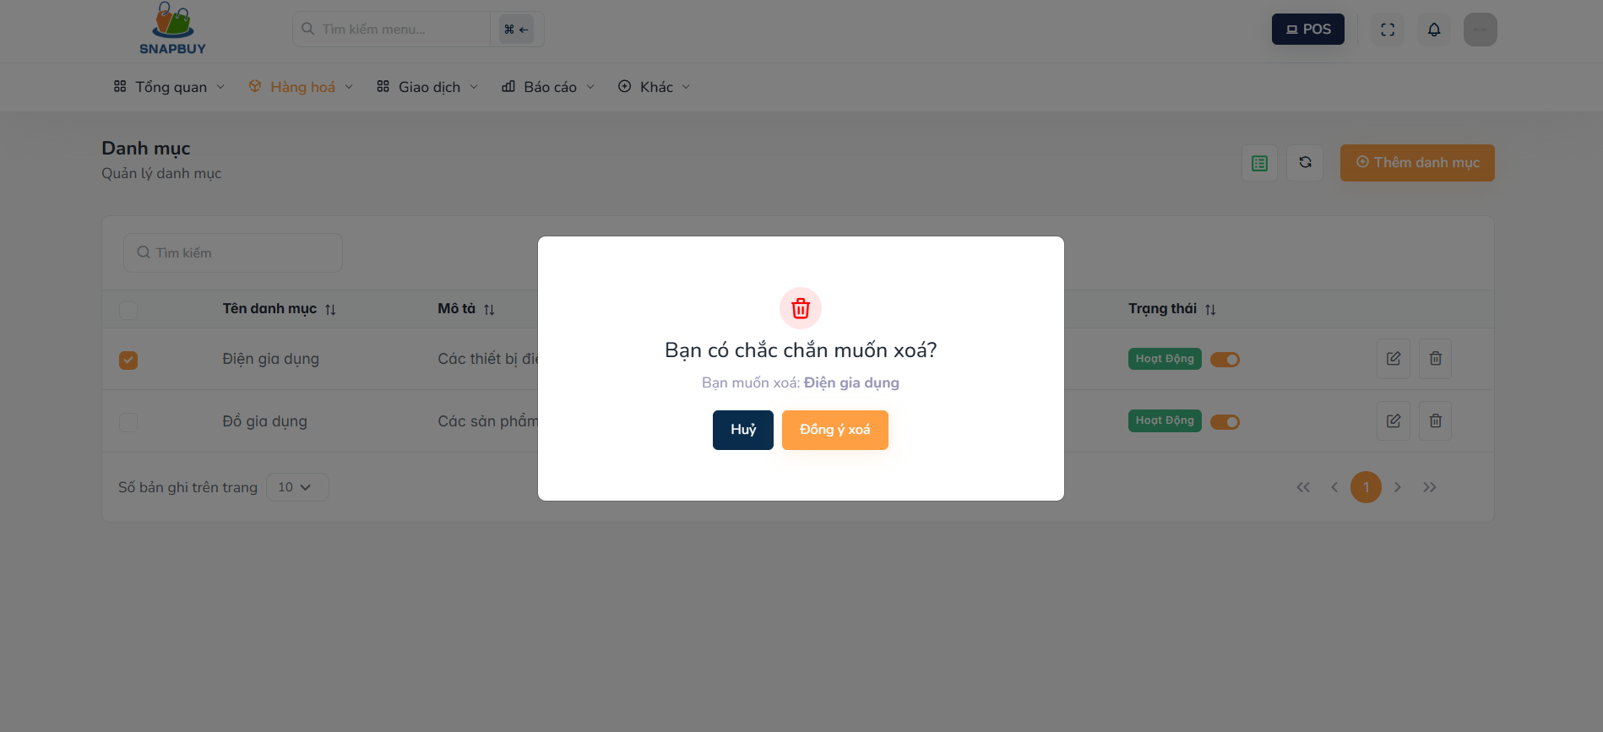
Figure 3.3.4. Delete Category
Step 1: At the “Delete Category” screen, the system displays a confirmation prompt asking whether the Admin wants to delete the selected category.
Step 2:To proceed with the deletion, click “Đồng ý xóa”.
Step 3:The system removes the category from the database.
- The category will no longer appear in the category list or be usable for any product.
Step 4:If the Admin does not want to delete the category, click “Hủy”.
- The system cancels the action and closes the form without making any changes.

3.4 Product management

3.4.1 Product list screen
- Description: Allows the administrator or user to view the list of all products available in the system, as well as perform product management tasks such as creating, updating, deleting, and searching for products.
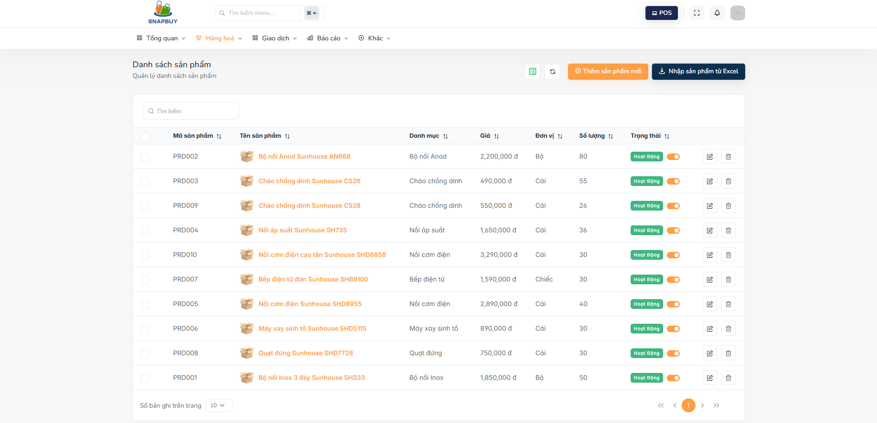
Figure 3.4.1.Product list
Click "Sản phẩm" the system displays the list of products
Search Product:
- Use the search bar to enter product name, code, or keywords.
- The system filters and displays matching products.
Create Product:
- Click the “Thêm sản phẩm” button.
- The system navigates to the Create Product screen.
Update Product:
- Click the Pen icon next to the product to edit.
- The system navigates to the Update Product screen.
Delete Product:
- Click the Delete icon next to the product.
- The system navigates to the Delete Product confirmation screen.

3.4.2 Product details screen
- Description: Allows the administrator or user to view detailed information of a specific product selected from the product list.

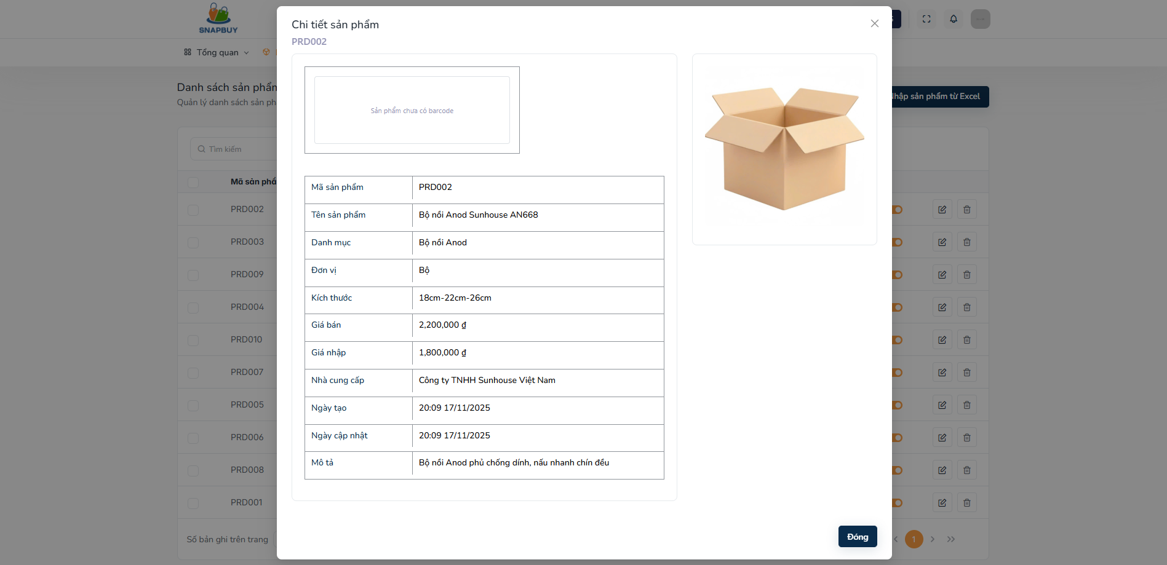
Figure3.4.2.Product detail
- Click on any product to display all product information.
- Review the displayed product details.
- To close the screen, click “Close”.

3.4.3 Create product screen
- Description: Allows the administrator to create and add a new product into the system with complete information.

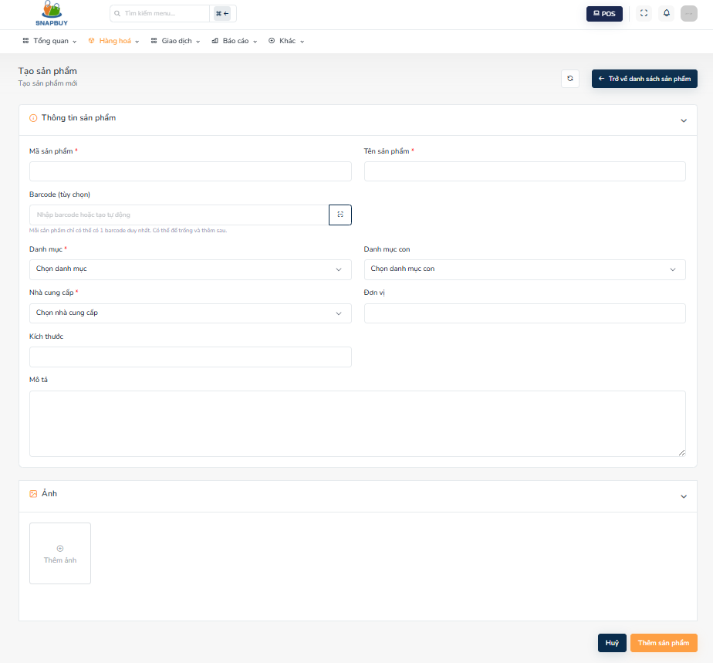
Figure3.4.3.Create Product
Step 1: At the Create Product screen, fill in the required fields:
- Mã sản phẩm: Unique product identifier.
- Tên sản phẩm: Name displayed to system users.
- Danh mục: Select the main category from the list.
- Danh mục con: Select a subcategory corresponding to the main category.
- Barcode: Barcode identifier for scanning and tracking.
- Đơn vị: Select product measurement unit.
- Kích thước: Provide physical dimensions.
- Nhà cung cấp: Choose from the supplier list.
- Mô tả: Additional product information.
- Ảnh: Upload a product image.
Step 2: After completing all fields, click “Thêm sản phẩm” to save the new product.
Step 3: If the Admin does not want to save, click “Hủy” to close the form without saving.

3.4.4 Update product screen
- Description: Allows the administrator to update all details of an existing product to ensure the system stays accurate and up-to-date.

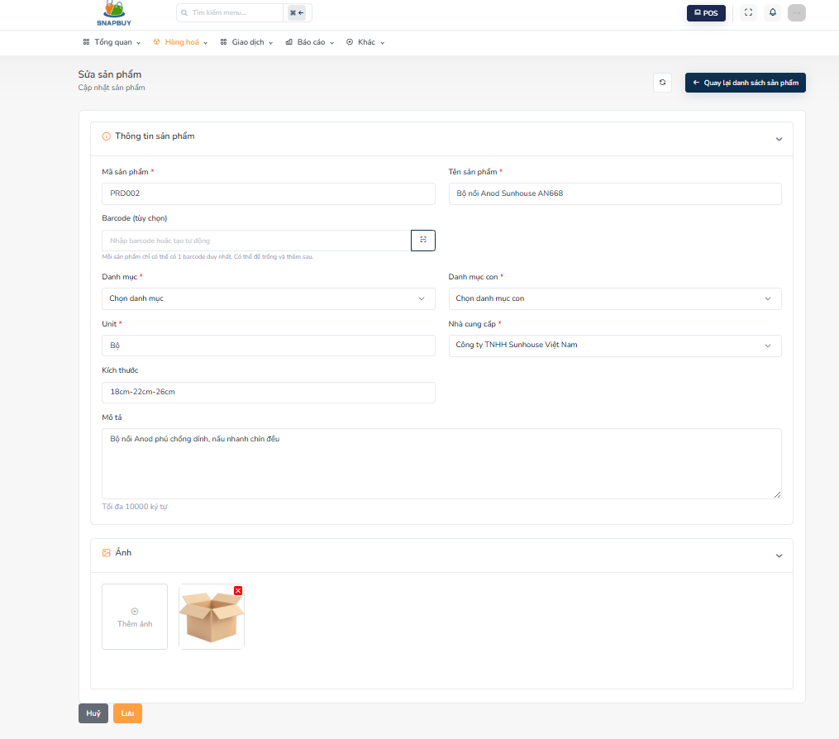
Figure 3.4.4. Update Product
Step 1: The system automatically loads existing product information into the form fields, including:
- Mã sản phẩm: Auto-filled product code.
- Tên sản phẩm: Pre-filled name for editing.
- Danh mục: Current main category selection.
- Danh mục con: Current subcategory selection.
- Barcode: Existing barcode.
- Đơn vị: Current measurement unit.
- Kích thước: Current dimensions.
- Nhà cung cấp: Current supplier.
- Mô tả: Existing description text.
- Ảnh: Current product image preview.
- Edit any fields as required.
Step 2: Click “Lưu” to save all updated information.
Step 3: To cancel without saving, click “Hủy”.

3.4.5 Delete product screen
- Description: Allows the administrator to delete or remove a product that is no longer used in the system.

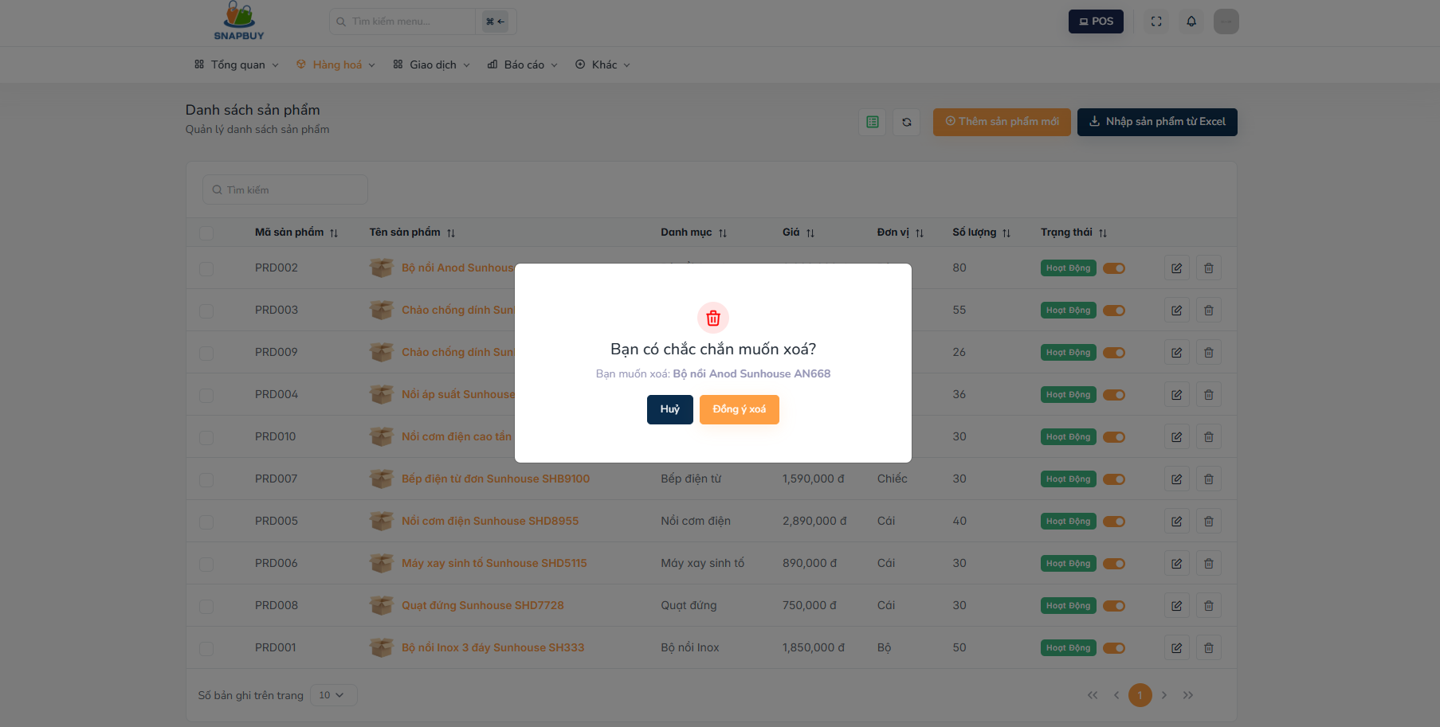
Figure 3.4.5.Delete product

Step 1: The system displays a confirmation dialog asking the Admin to confirm the deletion of the selected product.
Step 2: Click “Đồng ý xóa” to permanently remove the product from the system.
Step 3: If the Admin does not wish to delete, click “Hủy” to close the screen without making any changes.

3.5 Order management

3.5.1 Order list screen
- Description: Allows the user to view, search, and filter all orders in the system, as well as access detailed information for each order.

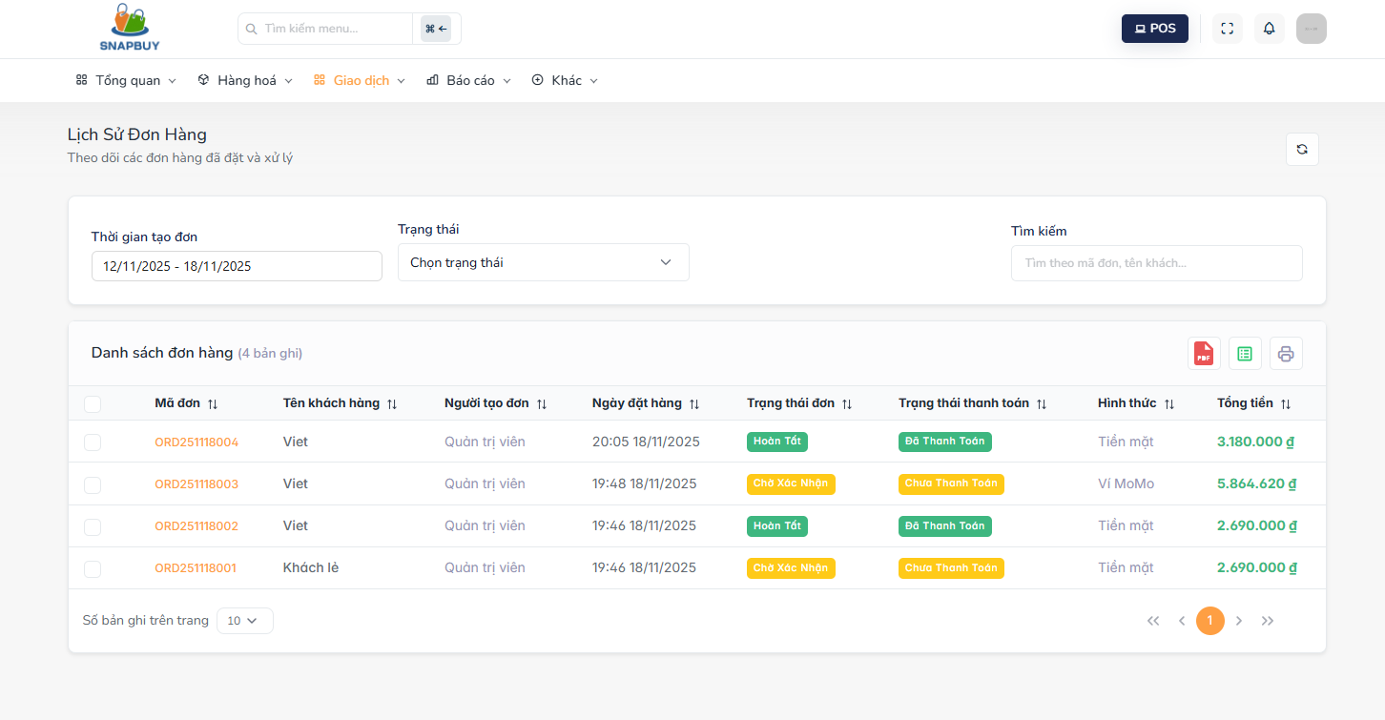
Figure 3.5.1. View Order List

Step 1: Click "Đơn hàng" the system displays all existing orders
Search Order:
- Enter order code, customer name, or keyword to search for specific orders.
- The system filters and displays matching results.
Filter Orders:
- Filter by order creation date.
- Filter by order status.
- Filtered results display immediately.
View Order Details:
- Click on an order item to open the Order Details screen.
- Full order information will be displayed.

3.5.2 Create orders screen
- Description: Allows the user to create a new order by selecting products, assigning a customer, and generating order totals.

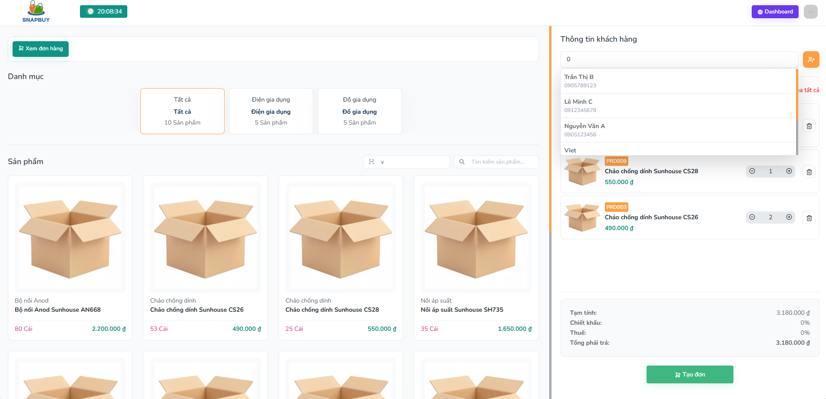
Figure 3.5.2. Create Orders
Step 1: At the Create Orders screen, perform the following:
- Select Products:
- “ Danh mục”:
  - Choose a product category to filter available products.
- “ Danh sách sản phẩm” :
  - Displays all products in the selected category.
  - Select products and specify quantities to add them to the order.
- Customer Information
- “ Thông tin khách hàng” :
- Choose or confirm customer details such as name, phone number, and address
- Order Summary
- Sản phẩm mua:
  - Shows all selected products including quantity, unit, and price.
- Tạm tính:
  - Displays subtotal of selected items.
- Chiết khấu:
  - Displays discount value based on customer accumulated points.
- Thuế:
  - Displays tax amount applied to the order.
- Tổng phải trả:
  - Displays the final amount payable after applying discounts and taxes.
Step 2: After completing all information, click “Tạo đơn” to save and create the new order.

3.5.3 Order details screen
- Description: Allows the user to view complete details of a selected order, including customer information, order status, and purchased products.

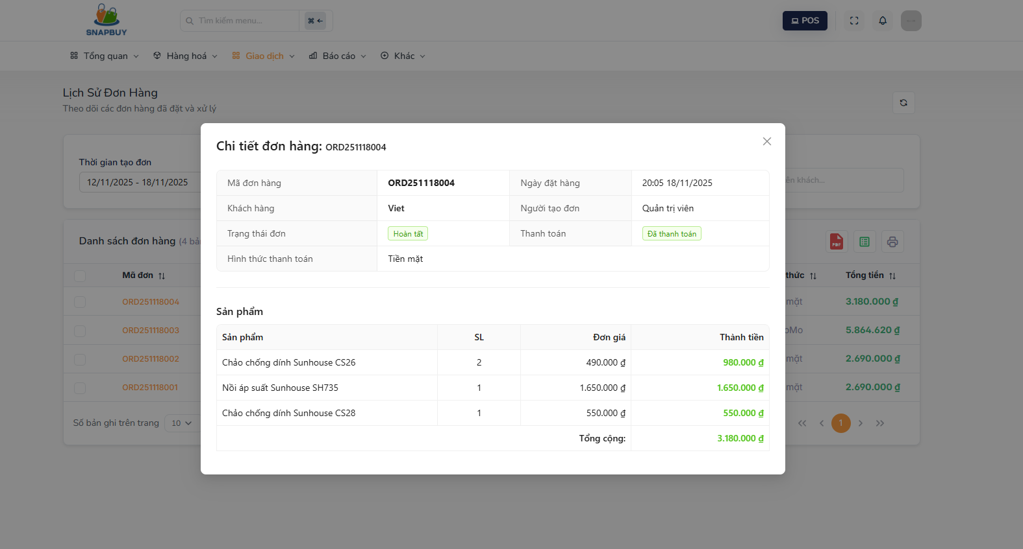
Figure 3.5.3. Order Details
- Select any order, the system displays full order information.
- The system also displays detailed information about the products in the order.

3.6 Account management

3.6.1 Account list screen
- Description: Allows the user to view all system accounts and perform account management actions such as creating, updating, and deleting accounts.

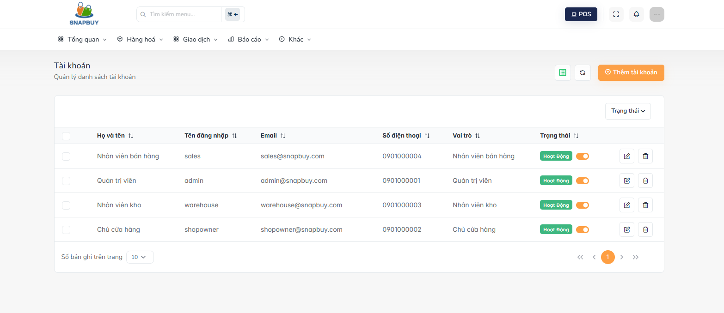
Figure 3.6.1.Account list

Login to Admin role and click " Tài khoản" , the system displays a table containing the following information
Create a New Account:
- Click the “Thêm tài khoản” button.
- The system navigates to the Add New Account screen.
Edit an Account:
- Click the Pen icon next to the account to update.
- The system opens the Edit Account screen.
Delete an Account:
- Click the Delete icon next to the selected account.
- The system opens the Delete Account confirmation screen.

3.6.3 Add new account screen
- Description: Allows the user to create a new account and add it to the system.

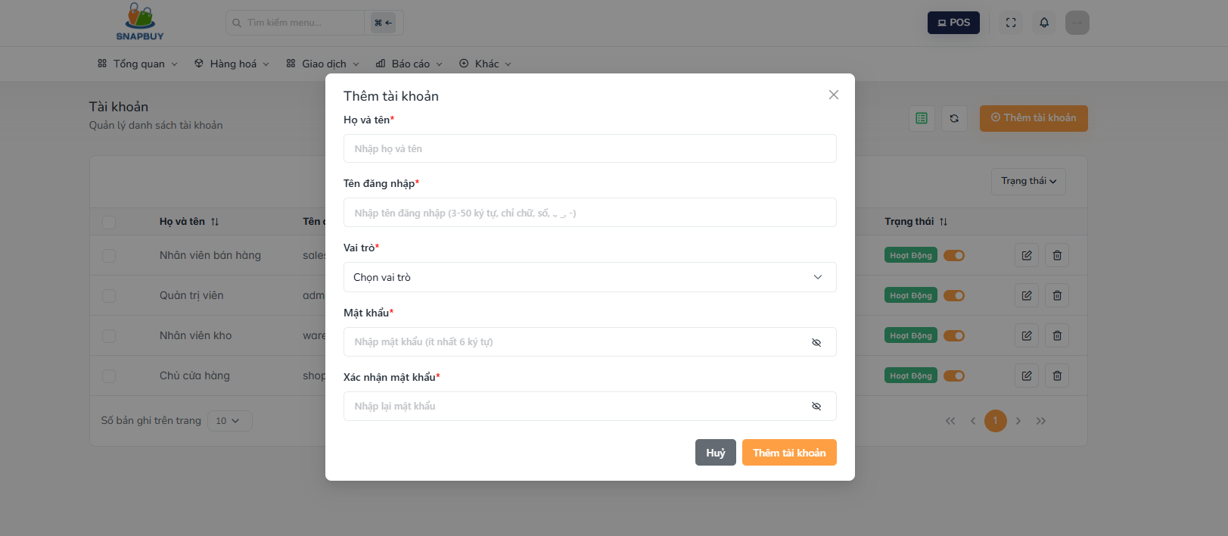
Figure 3.6.3.Add new account
Step 1: At the Add New Account screen, enter all required account information:
- Họ và tên: Enter the full name of the account user.
- Tên đăng nhập: Provide the login username.
- Email: Enter the email associated with the account.
- Số điện thoại: Enter the user’s phone number.
- Vai trò: Select a role from the dropdown menu.
- Mật khẩu: Enter a secure password for the new account.
- Xác nhận mật khẩu: Re-enter the password to confirm it matches.
Step 2:After entering all details, click “Thêm tài khoản” to save the new account into the system.
Step 3: To cancel the creation process, click “Hủy”.
- The system closes the form without saving any data.

3.6.4 Edit account screen
- Description:Allows the user to update the information of an existing account.

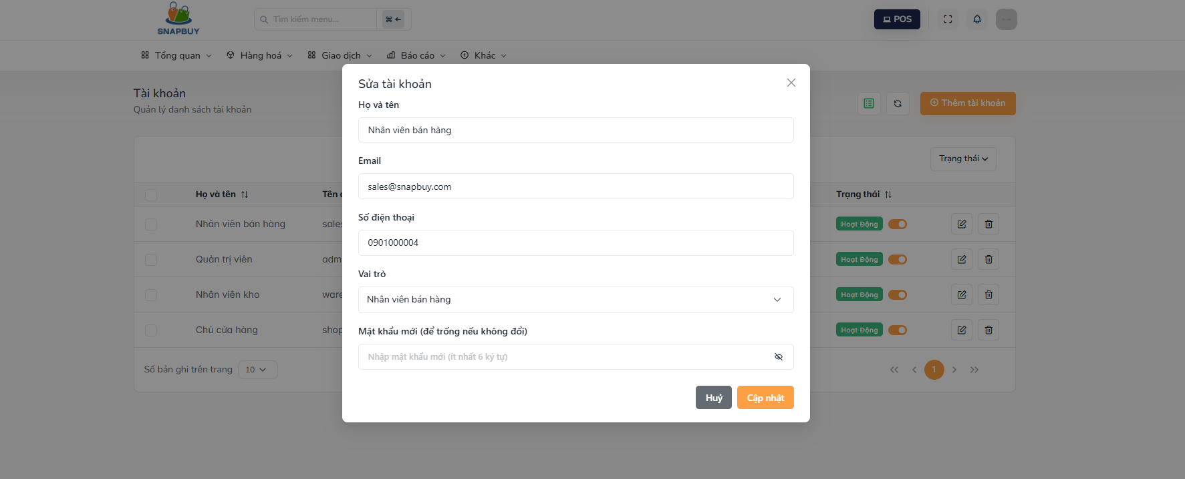
Figure 3.5.4.Edit account
Step 1: At the Edit Account screen, the system displays the current details of the selected account:
- Họ và tên: Editable full name.
- Tên đăng nhập: Editable username.
- Email: Editable email address.
- Số điện thoại: Editable phone number.
- Vai trò: Dropdown to change the user role.
- Mật khẩu mới: Enter a new password if needed (optional).
Step 2: Make any necessary updates to the account fields.
Step 3:Click “Cập nhật” to save the changes and update the account information.
Step 4: If the user does not wish to modify the account, click “Hủy”.
- The form closes without saving any changes.

3.6.5 Delete account screen
- Description:Allows the user to delete an account from the system.

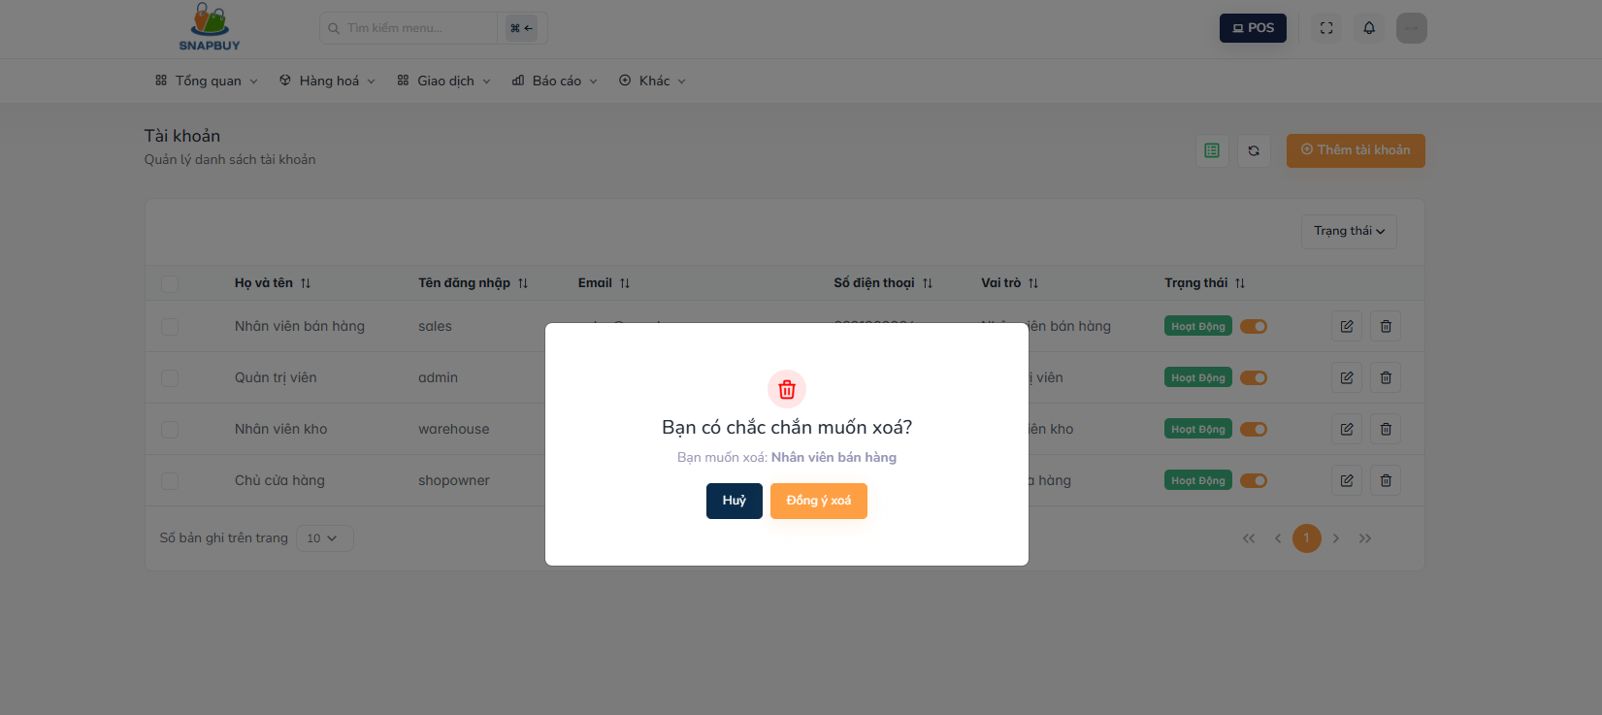
Figure 3.6.5.Delete account
Step 1: When accessing the Delete Account screen, the system displays a confirmation message asking whether the user wants to delete the selected account.
Step 2: Click “Đồng ý xóa” to permanently remove the account from the system.
Step 3: If the user decides not to proceed, click “Hủy”.
- The system cancels the deletion and closes the form.

3.7 Role Management

3.7.1 Role list screen
- Description: Allows the user to manage system roles, including viewing the role list, creating, updating, deleting roles, and filtering them by status.

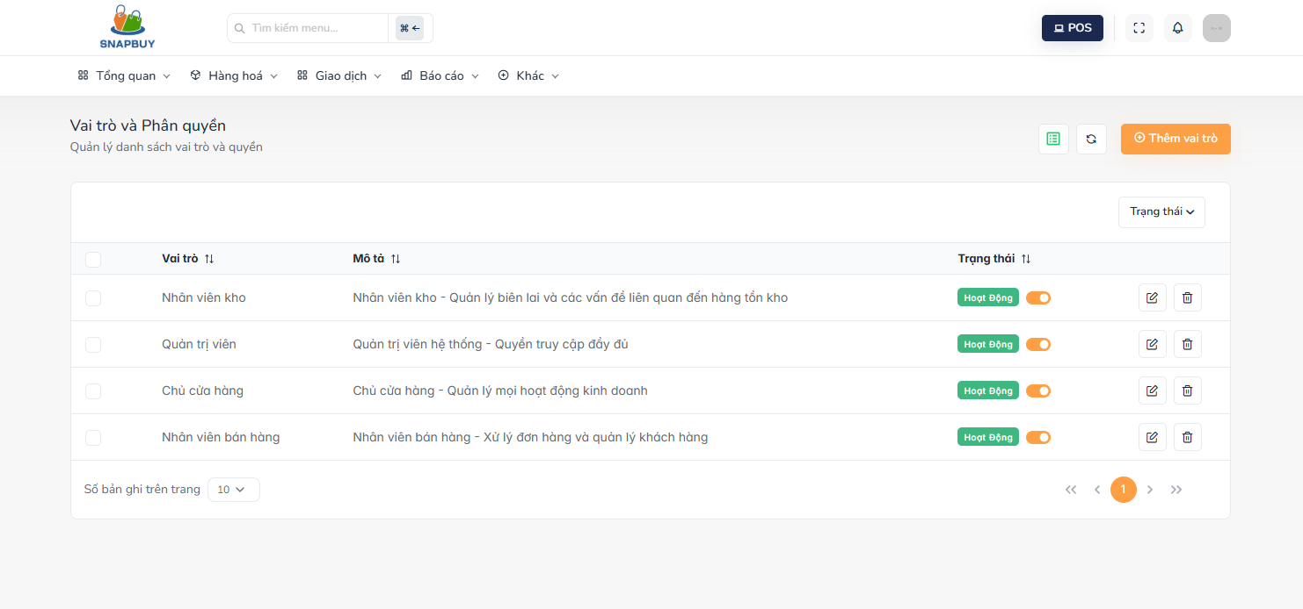
Figure3.7.1.Role list
Step 1: When accessing the Role List screen, the system displays all roles with the following information:
- Vai trò: The name of the role in the system.
- Mô tả: Description or purpose of the role, used to clarify permissions and responsibilities.
- Trạng thái: Current role status (Active/Inactive).
Filter Roles:
- Use the status filter to display roles by their current activation state.
Add New Role:
- Click the “Thêm vai trò” button.
- The system navigates to the Add New Role screen.
Update Role:
- Click the Pen icon next to the role you want to update.
- System opens the Edit Role screen.
Delete Role:
- Click the Delete icon to remove a selected role.
- The system opens the Delete Role confirmation screen.

3.7.2 Add new role screen
- Description: Allows the user to create and add a new role to the system.

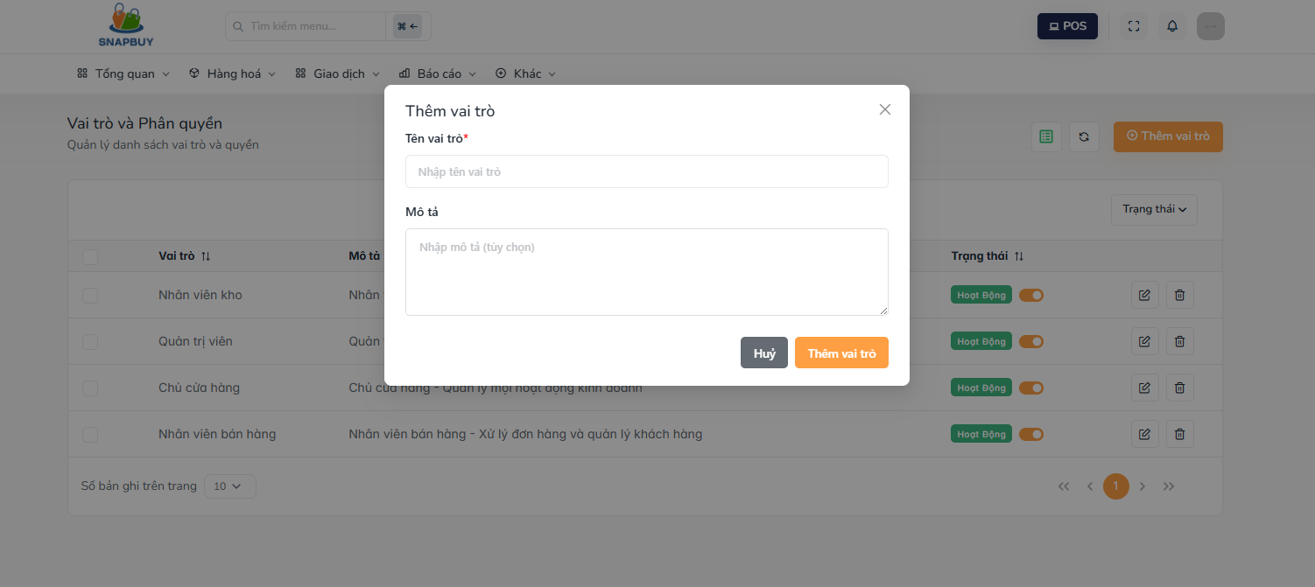
Figure3.7.2.Add new role
Step 1: At the Add New Role screen, enter the required role information:
- Tên vai trò: Enter the role name.
- Mô tả: Enter the description or purpose of this role.
Step 2: After completing all information, click “Thêm vai trò” to save the new role and add it to the system.
Step 3: If the user does not wish to proceed, click “Hủy”.
- The form closes without saving any information.

3.7.3 Edit role screen
- Description: Allows the user to update an existing role’s name and description.

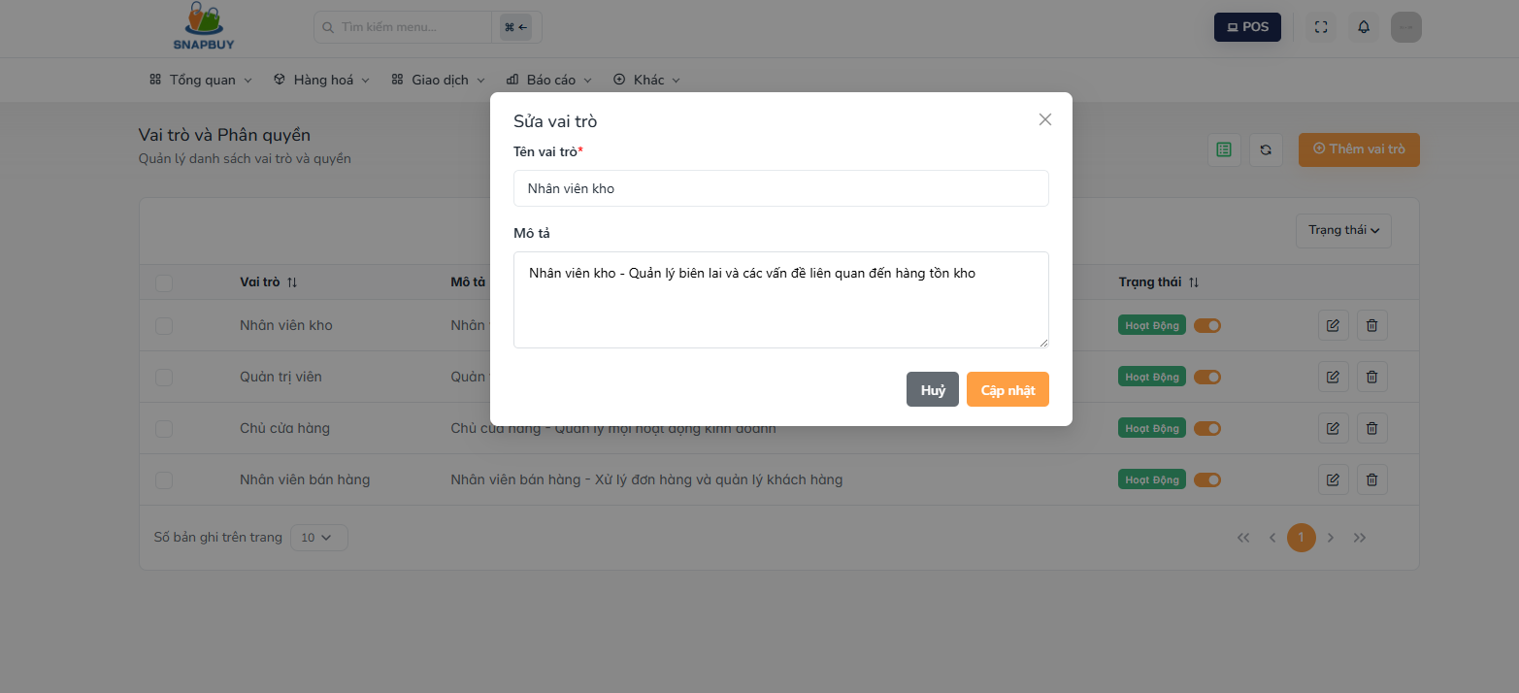
Figure3.7.3.Edit role
Step 1: At the Edit Role screen, the system automatically loads existing role information, including:
- Tên vai trò: Current role name (editable).
- Mô tả: Existing role description (editable).
Step 2: Update the fields as needed.
Step 3: Click “Cập nhật” to save all modified information.
Step 4: If the user does not want to apply any changes, click “Hủy”.
- The screen closes without saving changes.

3.7.4 Delete role screen
- Description: Allows the user to delete a role from the system.

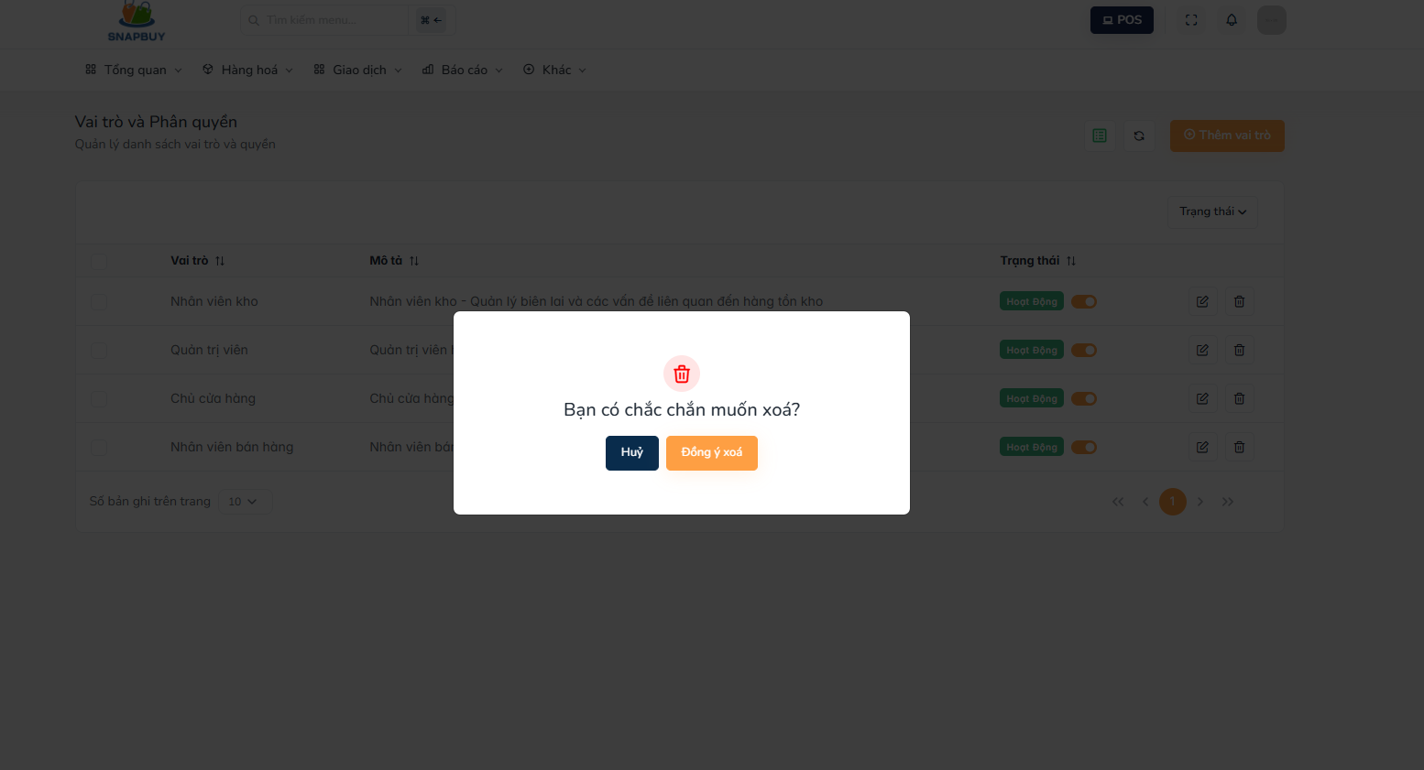
Figure3.7.4.Delete role
Step 1: At the Delete Role screen, the system displays a confirmation prompt asking the user to verify the deletion.
Step 2: Click “Đồng ý xóa” to permanently delete the selected role from the system.
Step 3: To cancel the action, click “Hủy”.
- The system closes the form without deleting anything.

3.8 Supplier Management

3.8.1 Supplier list screen
- Description:Allows the admin to view, search, create, update, and delete suppliers within the system.

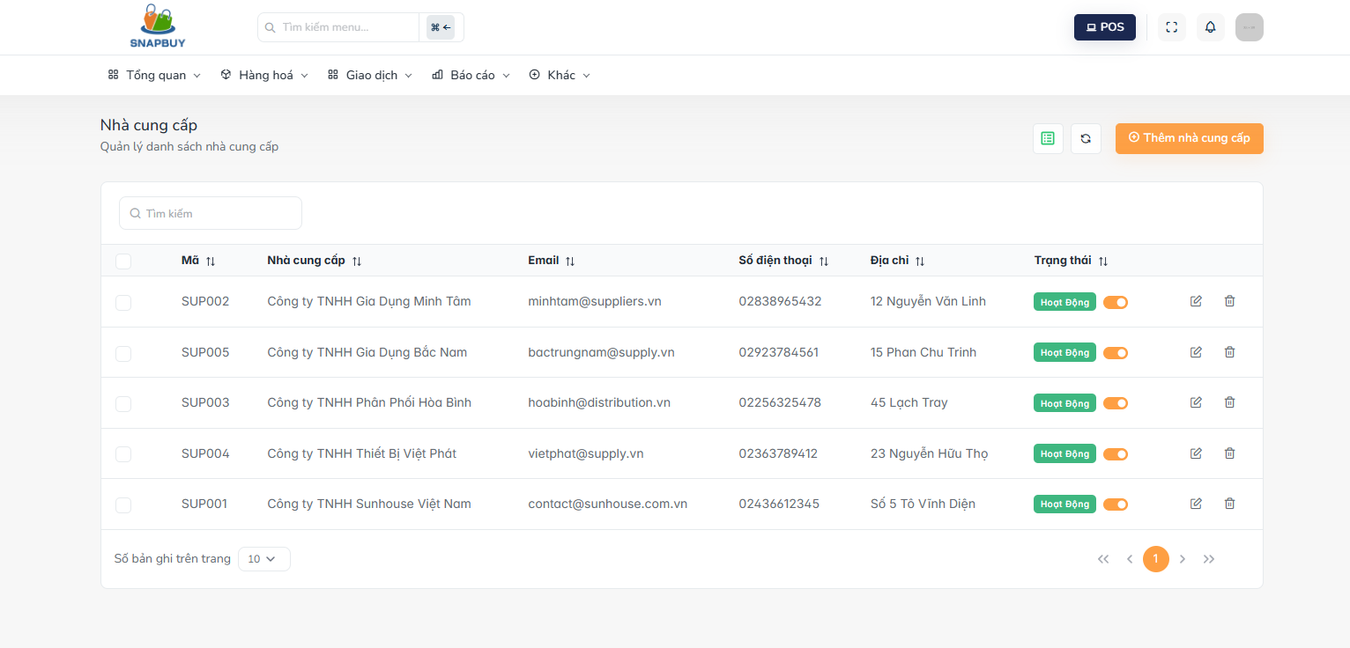
Figure 3.8.1. View Supplier List
Step 1: Click " Nhà cung cấp" , the system displays all suppliers with the following information:
- Mã: Unique supplier code for identification.
- Nhà cung cấp: Supplier’s name.
- Email: Supplier’s email address.
- Số điện thoại: Supplier’s contact phone number.
- Địa chỉ: Physical location or address of the supplier.
- Trạng thái: Supplier status (Active/Inactive).
Step 2: If user want to search supplier:
- Use the search bar to enter supplier name, phone number, or keyword.
- The system filters and shows matching supplier records.
Step 3: If user want to create supplier:
- Click “Thêm nhà cung cấp” to open the Create Supplier screen.
Step 4: If user want toUpdate Supplier:
- Click the Pen icon next to the supplier to edit.
- The system opens the Update Supplier screen.
Step 5: If user want toDelete Supplier:
- Click the Delete icon next to the supplier you want to remove.
- The system opens the Delete Supplier confirmation screen.

3.8.2 Create supplier screen
- Description: Allows the user to create a new supplier and add it to the system.

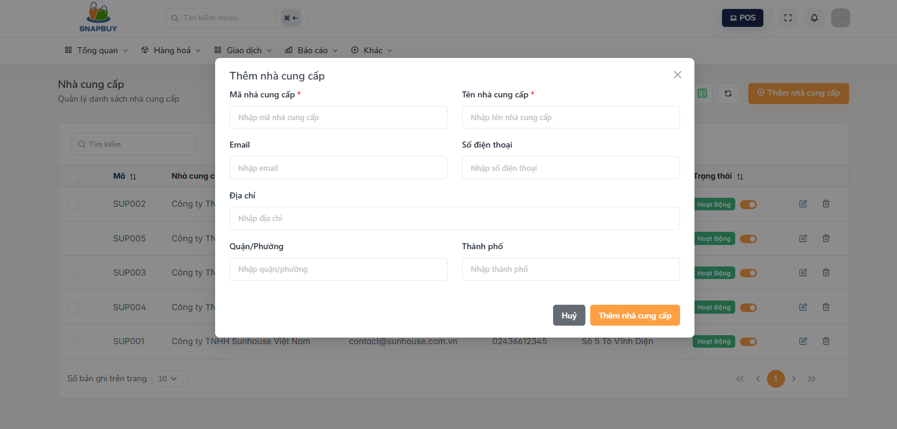
Figure 3.8.2. Create Supplier
Step 1: At the Create Supplier screen, fill in the following required information:
- Mã nhà cung cấp: Enter a unique supplier code.
- Tên nhà cung cấp: Enter the supplier’s full name.
- Email: Enter the supplier’s email address.
- Số điện thoại: Provide the supplier’s contact number.
- Địa chỉ: Enter the detailed supplier address.
- Quận/Phường: Enter the supplier’s district or ward.
- Thành phố: Enter the supplier’s city.
Step 2: After completing all fields, click “Thêm nhà cung cấp” to save and add the new supplier to the system.
Step 3: To cancel the creation process, click “Hủy”.
- The form will close without saving any entered information.

3.8.4 Update supplier screen
- Description: Allows the user to update existing supplier information stored in the system.

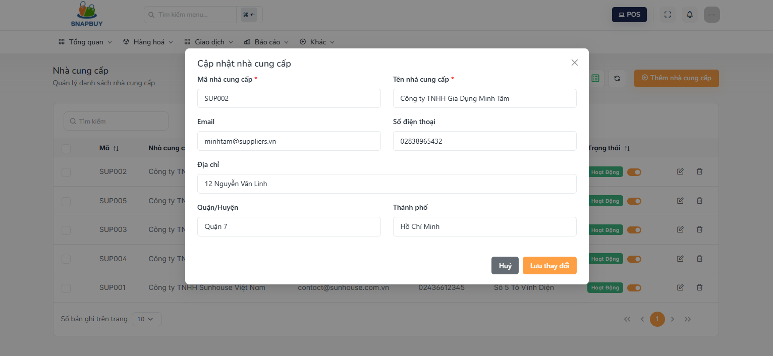
Figure 3.8.4. Update Supplier
Step 1: At the Update Supplier screen, the system automatically loads the current supplier details, including:
- Mã nhà cung cấp: Pre-filled and may be locked from editing.
- Tên nhà cung cấp: Editable supplier name.
- Email: Editable email address.
- Số điện thoại: Editable contact number.
- Địa chỉ: Editable full address.
- Quận/Phường: Editable district/ward.
- Thành phố: Editable city.
Step 2: Modify any fields as needed to update the supplier’s information.
Step 3: Click “Lưu thay đổi” to save the updated information.
Step 4: If the user does not want to proceed, click “Hủy”.
- The system will close the form without saving changes.

3.8.5 Delete supplier screen
- Description: Allows the user to delete a supplier from the system.

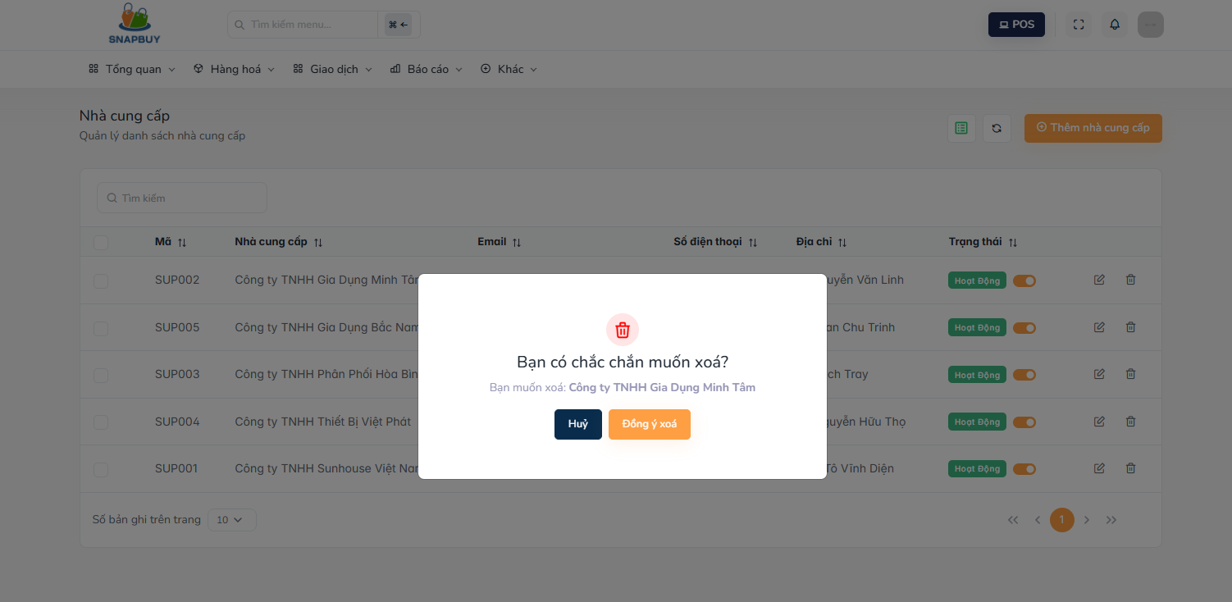
Figure 3.8.5. Delete Supplier

Step 1: The system opens a confirmation dialog asking whether the user wants to delete the selected supplier.
Step 2: Click “Đồng ý xóa” to permanently remove the supplier from the system.
Step 3: To cancel the deletion, click “Hủy”.
- The form closes without deleting the supplier.

3.9 Customer Management

3.9.1 Customer list screen
- Description:Allows the user to view, search, update, customers stored in the system.
Step 1: User click on “Giao dịch” and select on “ Khách hàng “ then the system displays a list of customers with the following information:
- Mã KH: Unique customer code.
- Tên khách hàng: Full name of the customer.
- Số điện thoại: Customer’s contact number.
- Giới tính: Customer’s gender.
- Tích điểm: Customer’s accumulated loyalty points.
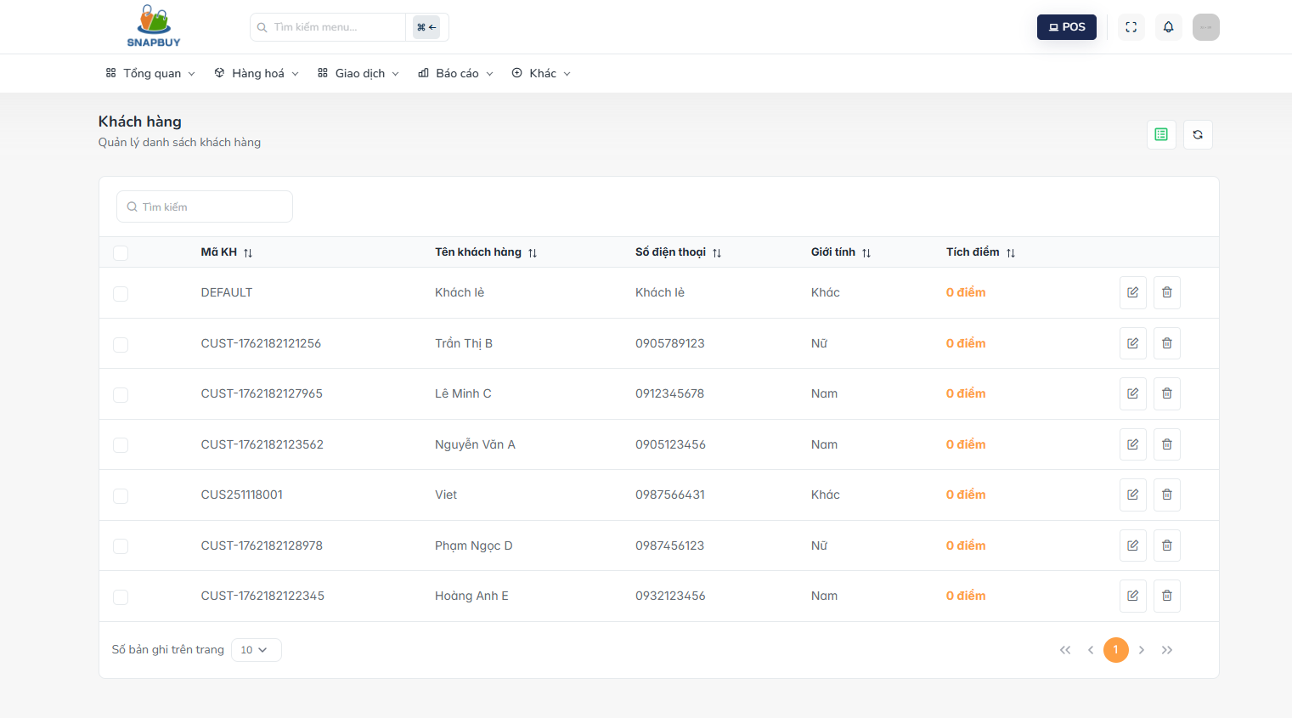
Figure 3.9.1.Customer list
Step 2: If user want to search customer :
- Use the search bar to input the customer name, phone number, or keyword.
- The system filters and displays matching customer results.
Step 3: If user want to update customer
- Click the Pen icon next to the customer you want to edit.
- The system navigates to the Edit Customer screen.
Step 4: If user want to delete customer:
- Click the Delete icon next to the customer.
- The system opens the Delete Customer confirmation screen (if applicable).

3.9.2 Add new customer screen
- Description: Allows the user to create and add a new customer into the system.
Step 1: Click on "Thêm khách hàng " at the customer list screen . At the Add New Customer screen, fill in the following fields:
- Tên khách hàng: Enter the full name of the customer.
- Số điện thoại: Enter the customer’s phone number.

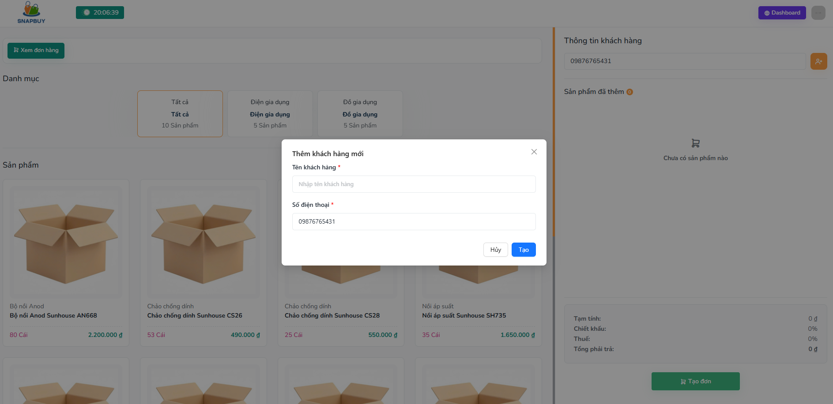
Figure 3.9.2.Add new customer
Step 2: After providing all necessary information, click “Tạo” to save and add the new customer to the system.
Step 3:To cancel the creation process, click “Hủy”.
- The form closes without saving data.

3.9.3 Edit customer screen
- Description: Allows the user to update the information of an existing customer.
Step 1: Select the customer you want to update and then click the pen icon. When opening the Edit Customer screen, the system automatically loads the existing customer details:
- Họ và tên: Pre-filled with the customer’s current name. Editable.
- Số điện thoại: Pre-filled with the customer’s current contact number. Editable.

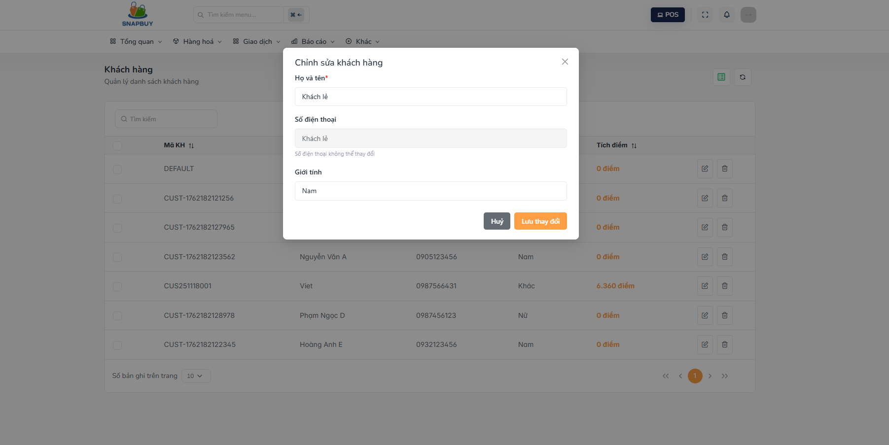
Figure 3.9.3. Edit customer
Step 2: Modify any customer information as needed.
Step 3: Click “Lưu thay đổi” to save and update the customer’s information.
Step 4: If the user decides not to make changes, click “Hủy”.
- The system closes the form without saving updates.

3.10 Purchase order management

3.10.1 Purchase order list screen
- Description: This screen allows the user to manage purchase orders in the system, including viewing, creating, updating, searching, approving, canceling, and confirming receipt of purchase orders.
Step 1 : Click on "Đơn đặt hàng", the system displays a list of all purchase orders with the following information:
- Mã tạo đơn: Unique code generated for each purchase order.
- Nhà cung cấp: Name of the supplier associated with the purchase order.
- Người tạo đơn: Name of the user who created the purchase order.
- Ngày tạo phiếu: Date and time the purchase order was created.
- Ngày nhận hàng: Expected or actual date the goods were received.
- Tổng tiền: Total monetary value of the purchase order.
- Trạng thái: Current purchase order status (e.g., Chờ duyệt, Đã duyệt, Đã nhận hàng, Đã hủy).

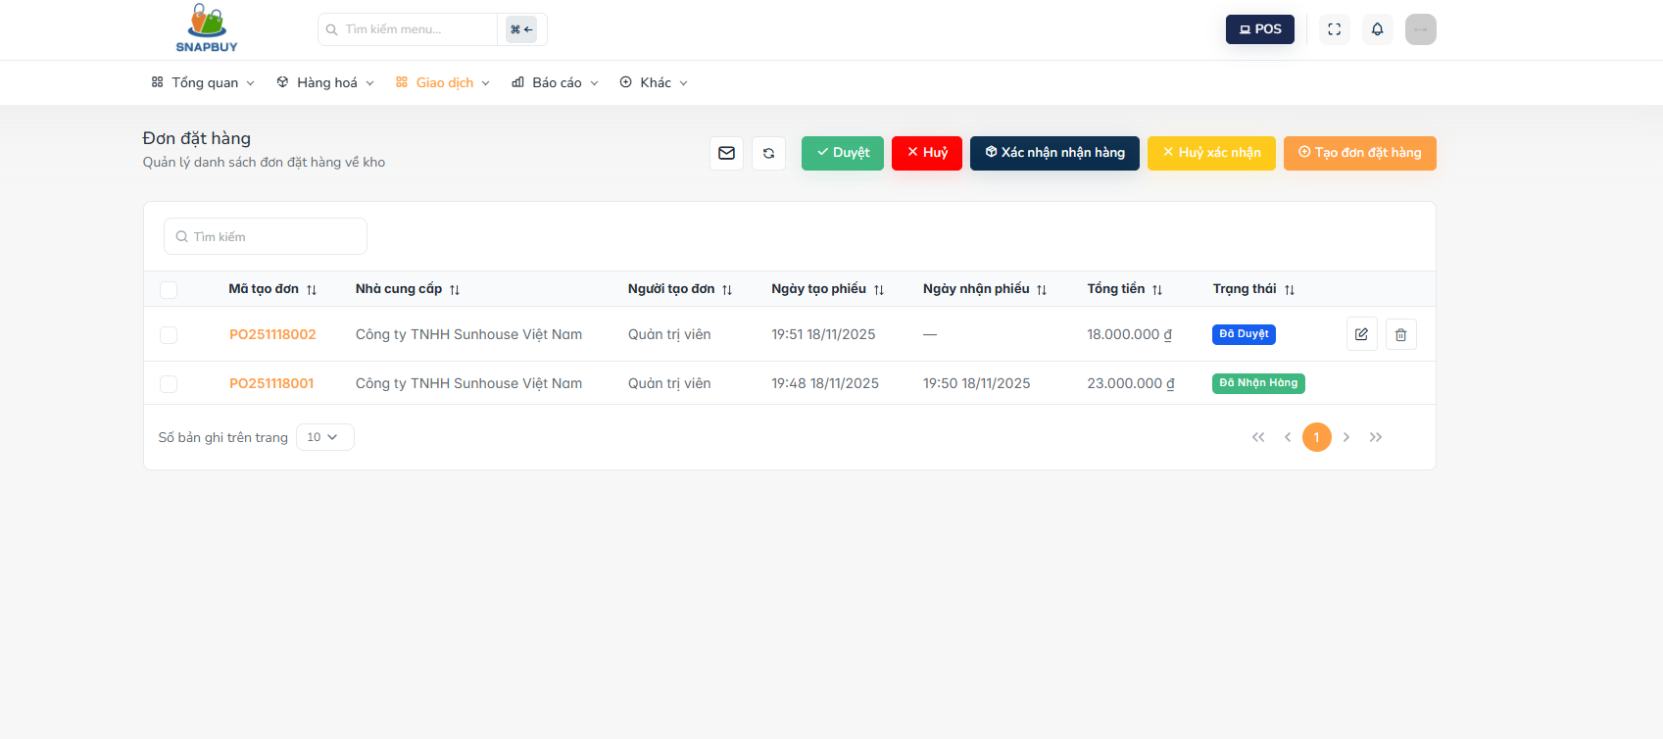
Figure 3.10.1. View Purchase Order
Step 2 : If user want to search purchase order:
- Use the search box to look up purchase orders by code, supplier name, creator, or other related keywords.
- The system filters and displays matching purchase orders immediately.
Step 3 : If user want to create new purchase order:
- Click “Tạo đơn đặt hàng”.
- The system navigates to the Create Purchase Order screen.
Step 4 : If user want to approve purchase order:
- Click “Duyệt” to approve a purchase order that is currently in "Chờ duyệt" status.
- The system updates the status to "Đã duyệt".
Step 5 : If user want to cancel purchase order:
- Click “Hủy” to cancel the purchase order.
- This action is only available for purchase orders in a status where cancellation is allowed .
Step 6 : If user want to confirm goods received:
- Click “Xác nhận nhận hàng” to confirm that the goods have been received.
- The system updates the purchase order status accordingly
Step 7 : If user want to revert receipt confirmation:
- Click “Hủy xác nhận” to undo the receipt confirmation.
- The system returns the purchase order to its previous status before confirmation.
Step 8 : If user want to update purchase order:
- Click the Pen icon next to a purchase order.
- The system opens the Edit Purchase Order screen, allowing the user to update the order details (if its status permits modification).

3.10.2 Purchase order detail screen
- Description: This screen allows the user to view complete details of a selected purchase order, including supplier information, product list, received quantities, status, and notes.
Step 1: When accessing the Purchase Order Detail screen, the system displays the full information of the selected purchase order, including:
- Mã tạo đơn: Displays the unique system-generated code of the purchase order.
- Nhà cung cấp: Shows the name of the supplier related to the purchase order.
- Người tạo đơn: Displays the name of the user or staff who created the purchase order.
- Ngày tạo phiếu: Shows the date and time when the purchase order was created.
- Ngày nhận hàng: Displays the date when the goods were expected or actually received.

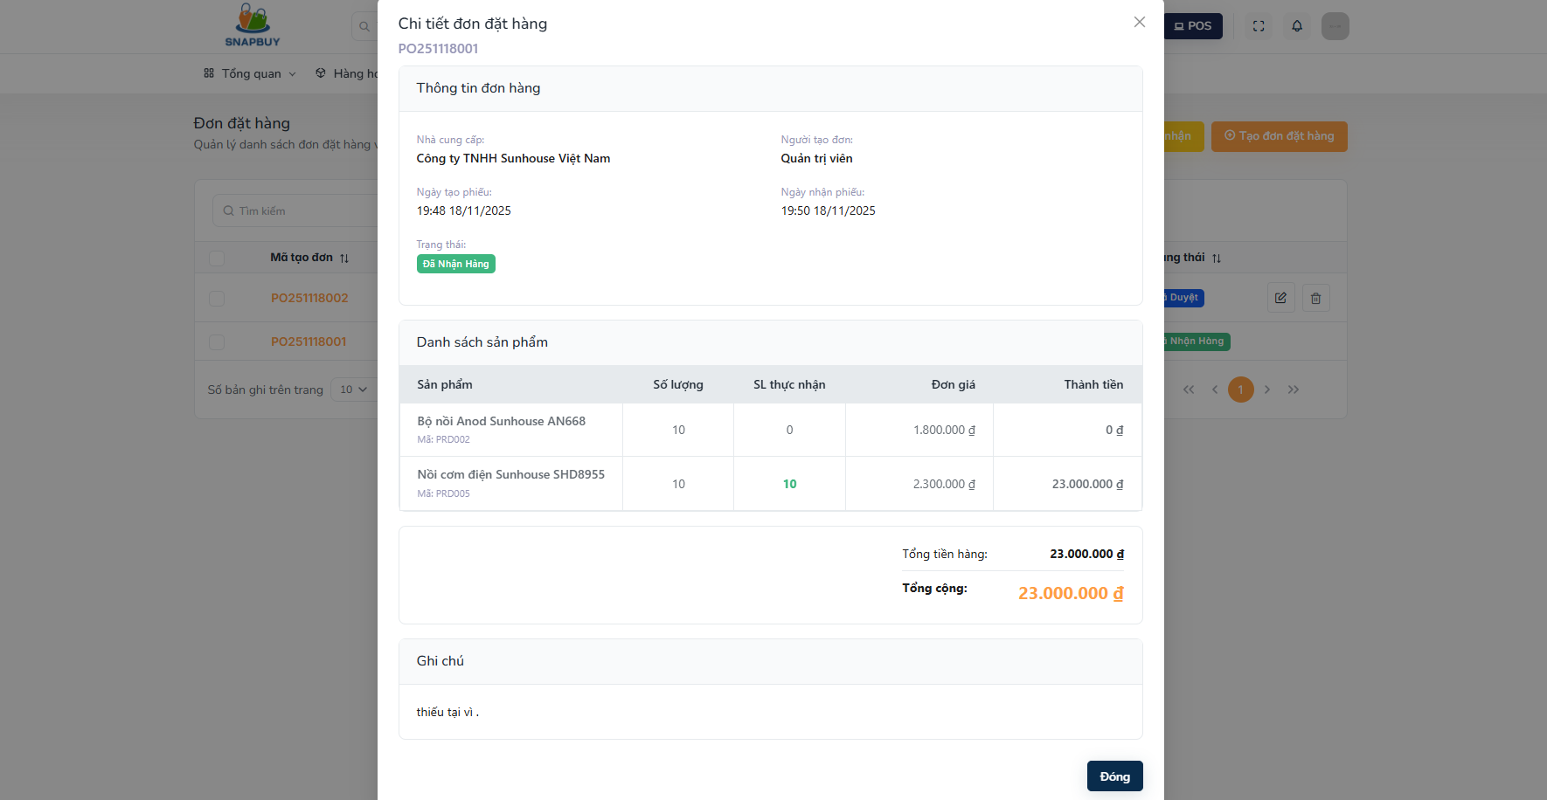
Figure 3.10.2. View Purchase Order Detail
Step 2 : View Product Details: The product table lists all products included in the purchase order, showing:
- Sản phẩm: Product name and SKU/code.
- Số lượng: The quantity ordered.
- SL thực nhận: Actual received quantity (if goods are partially or fully received).
- Đơn giá: Unit price of the product.
- Thành tiền: Total value of each product line.
At the bottom of the table, the system displays:
- Tổng tiền hàng: Total cost of all products in the purchase order.
- Tổng cộng: Final total amount of the purchase order.
Step 3 Displays the current status of the purchase order, such as: “Chờ duyệt” ,“Đã duyệt”, “Đã nhận hàng”, ”Hủy”
Step 4 :Displays additional notes, comments, or remarks added to the purchase order (e.g., damaged goods, missing quantity, delivery comments).

3.10.3 Create purchase order screen
- Description: This screen allows the user to create a new purchase order by selecting a supplier, adding products, entering quantities and prices, and completing order information before saving it into the system.

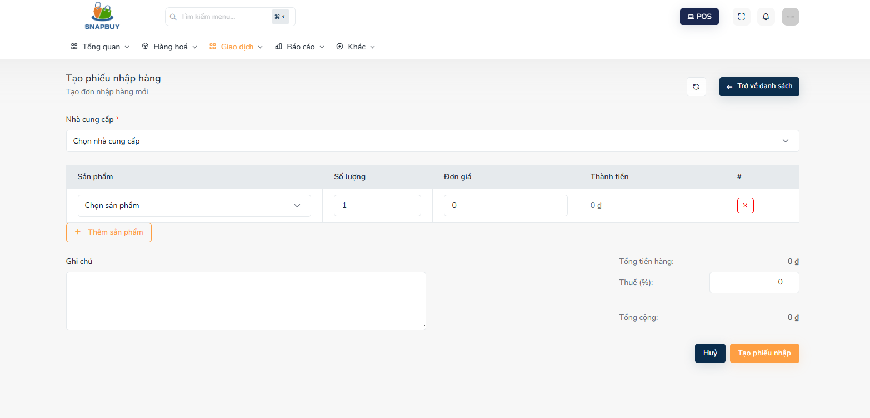
Figure 3.10.3. Create Purchase Order
Step 1: Select Supplier
- Use the dropdown menu to select the supplier who will provide the goods.
- This is a required field before products can be added.
Step 2. Add products to the purchase order. For each product line:
- Chọn sản phẩm: Select a product from the dropdown list.
- Số lượng: Enter the quantity of the product to be ordered.
- Đơn giá: Enter the unit price for the selected product.
- Thành tiền: The system automatically calculates the total amount for the line item: Thành tiền = Số lượng × Đơn giá
- Thêm sản phẩm: Click this button to add the selected product line to the order list.
- Additional product rows can be added as needed.
- X (Delete icon): Remove a product row if it was added incorrectly.
Step 3 : Add notes
- Ghi chú: Enter any remarks or additional information related to the purchase order (optional).
Step 4 :Tax and total amount calculation
- Thuế (%):Enter the tax percentage to be applied to the purchase order.
- The system then automatically calculates:
- Tổng tiền hàng: Total before tax.
- Tổng cộng: Final amount including tax.
Step 5: Save or cancel the purchase order
- Tạo phiếu nhập: Save the purchase order and create it in the system.
- Hủy: Cancel the creation process and close the form without saving any information.
- Trở về danh sách: Navigate back to the Purchase Order List screen.

3.10.4 Update purchase order screen
- Description: This screen allows the user to update an existing purchase order, including modifying supplier information, editing product quantities or prices, adding new products, adjusting notes, and recalculating totals before saving changes.

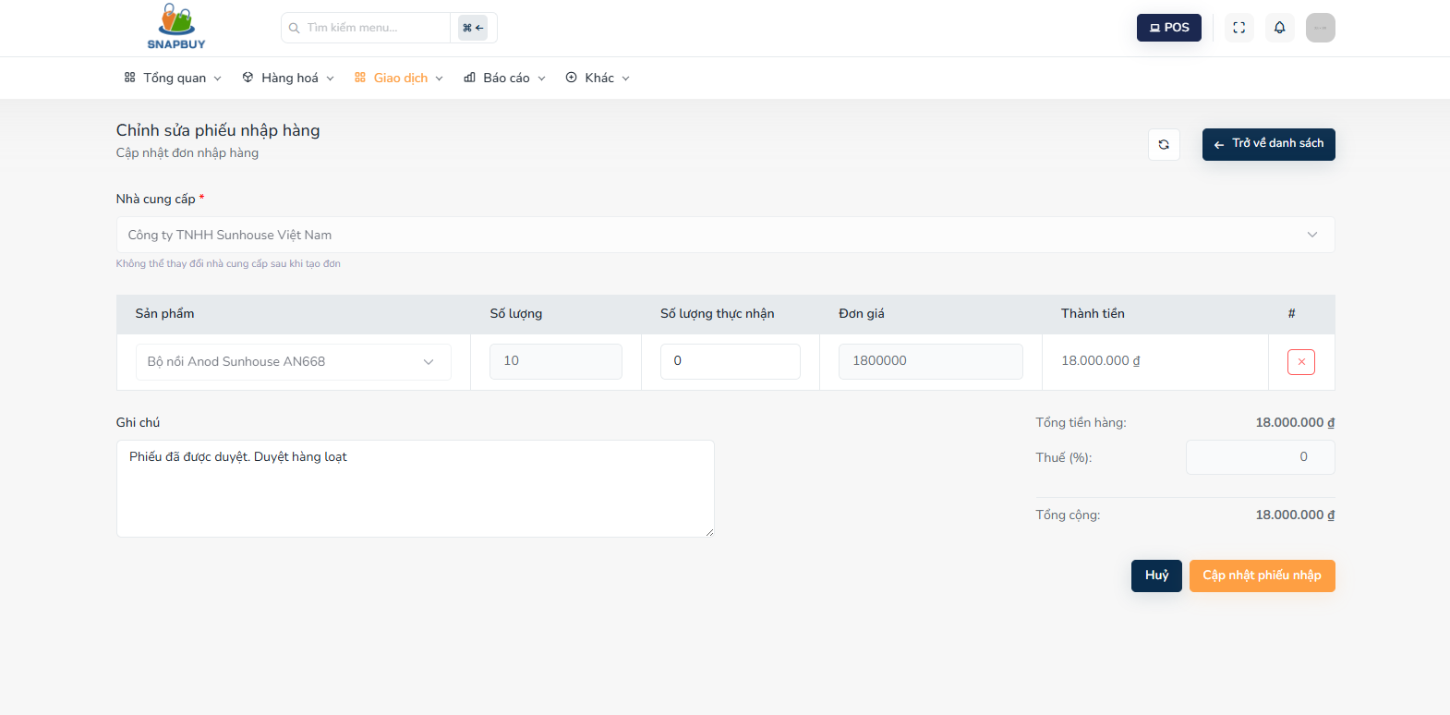
Figure 3.10.4. Update Purchase Order
Step 1: Supplier information
- Chọn nhà cung cấp: Displays the supplier associated with the purchase order.
- The field is pre-filled with the current supplier.
Step 2: Manage products in the purchase order .Existing items appear in a list with editable fields:
Chọn sản phẩm: Shows existing products already part of the purchase order. Can be used as a dropdown to add new products to the order.
- Số lượng:Pre-filled with the ordered quantity for each product.
- Can be edited if the quantity needs to be adjusted.
- Số lượng thực nhận:Displays the quantity of goods actually received
- May be editable only after goods receipt confirmation.
Đơn giá:Pre-filled unit price of the product.
- Can be updated if there is a price change.
- Thành tiền: Automatically calculated: Thành tiền = Số lượng × Đơn giá
- Updates dynamically when quantity or price changes.
X (Delete icon): Removes a product line from the purchase order if no longer needed.
Thêm sản phẩm: Allows the user to add a new product line with quantity and price.
Step 3: Add notes
- Ghi chú: Displays existing notes related to the order.
- Can be updated with new comments or additional information.
Step 4: Tax & Totals
- Thuế (%):Displays the tax percentage applied to the order. Editable if tax needs adjustment.
The system automatically updates:
- Tổng tiền hàng (Total before tax)
- Tổng cộng (Final total with tax)
Step 5. Save or cancel the update
- Cập nhật phiếu nhập: Saves all changes and updates the purchase order in the system.
- Hủy: Cancels the update and closes the form without saving any changes.
- Trở về danh sách: Navigates back to the Purchase Order List screen.

3.11 Promotion Management

3.11.1 View promotion list
- Description: This screen allows the user to view, filter, create, edit, and delete promotions available in the system.
Step 1.When accessing the Promotion List screen, the system displays all existing promotions with the following information:
- Tên khuyến mãi: Displays the promotion name.
- Loại giảm giá: Shows the promotion’s discount type (e.g., percentage, fixed amount).
- Giá trị: Displays the discount value corresponding to the selected discount type.
- Ngày bắt đầu: The date the promotion starts.
- Ngày kết thúc: The date the promotion ends
- Số sản phẩm: Number of products included or affected by the promotion.
- Trạng thái: Current status of the promotion
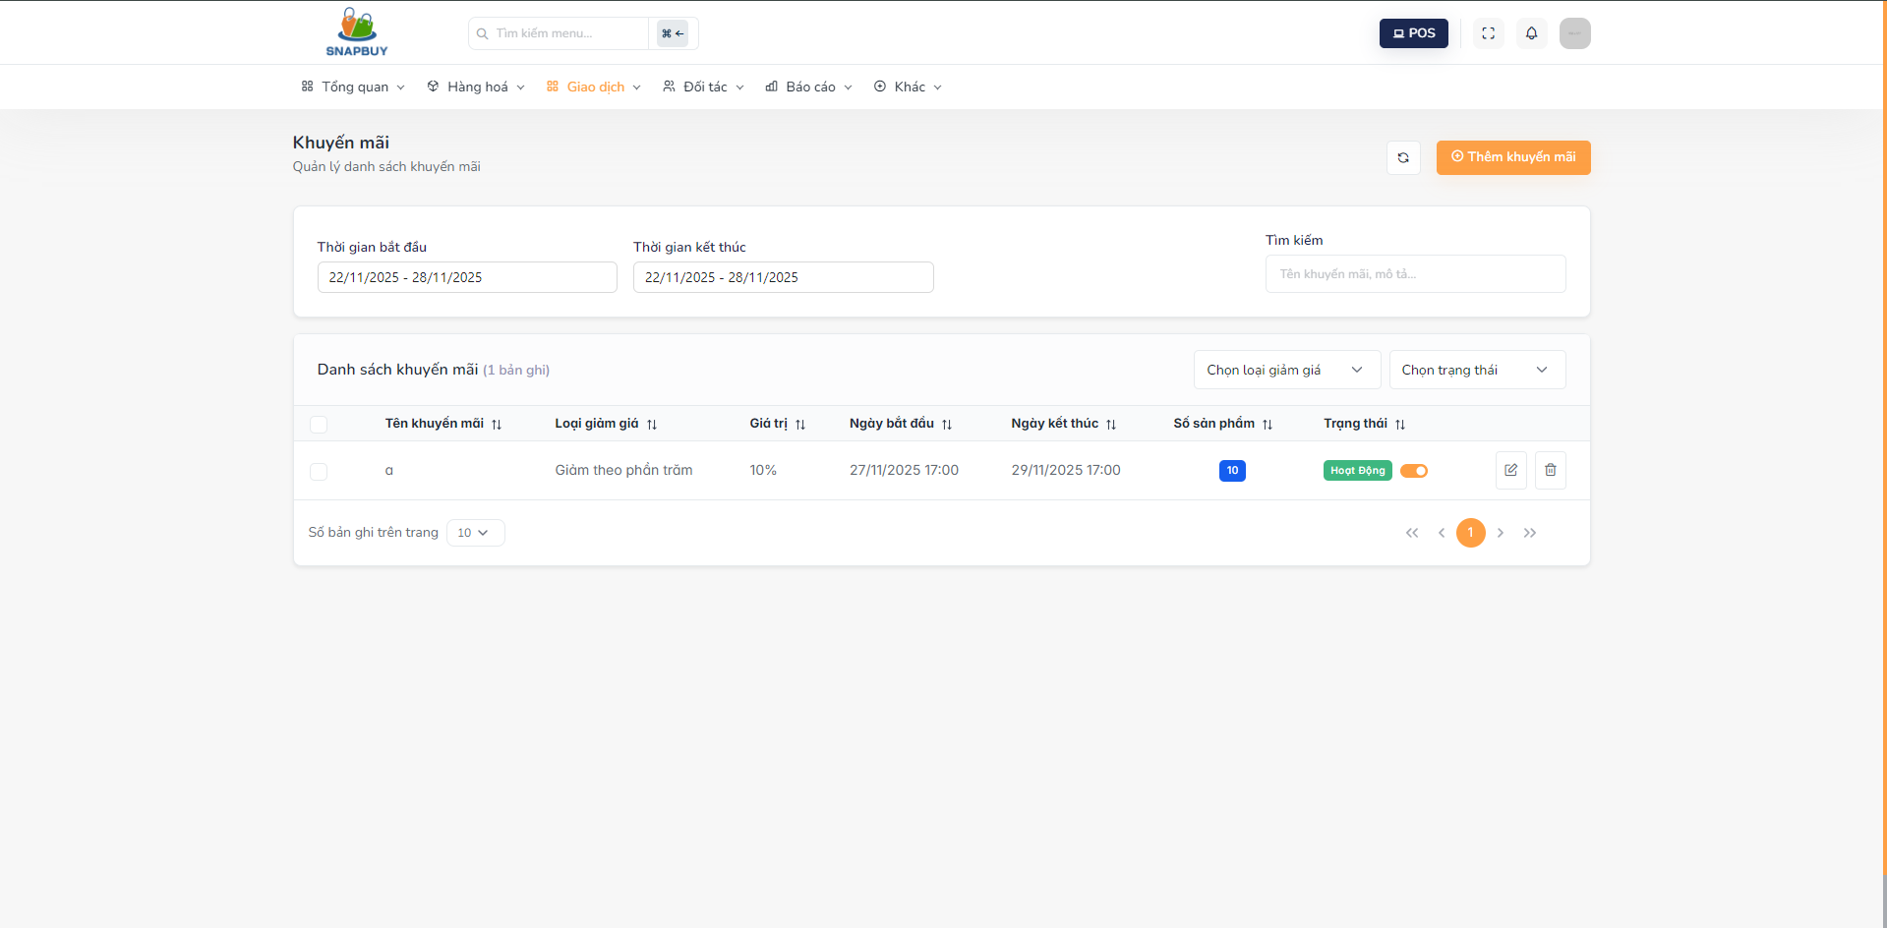
Figure 3.11.1. View Promotion List

Step 2: If user want to filter promotions
- Select "Chọn loại giảm giá" :Allows filtering promotions by discount type.
- Select "Chọn trạng thái" : Filters the promotion list based on their current status.
Step 3: If user want to add new promotion
- Click “Thêm khuyến mãi”.
- The system opens the Add New Promotion screen.
Step 4 : If user want to update promotion
- Click the Pen icon next to the promotion you want to update.
- The system opens the Edit Promotion form.
Step 5: If user want to delete promotion
- Click the Delete icon next to the promotion to remove.
- The system opens a confirmation dialog for promotion deletion.

3.11.2 Add new promotion
- Description: This screen allows the user to create a new promotion by specifying the discount type, discount value, promotion timeframe, and applicable products.

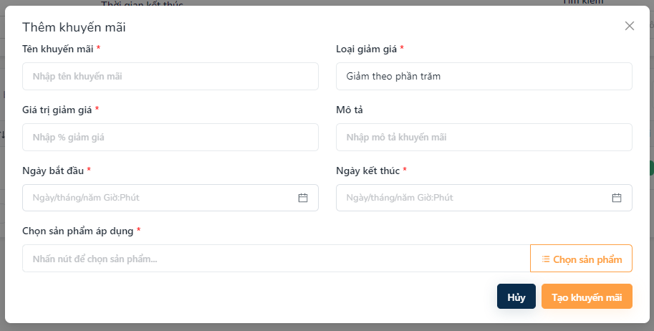
Figure 3.11.3. Add New Promotion
Step 1: Input promotion information
- Tên khuyến mãi: Enter the name of the new promotion.
- Loại giảm giá: Select the promotion’s discount type from the dropdown (e.g., fixed amount, percentage).
- Giá trị giảm giá: Enter the discount amount according to the selected type.
- Ngày bắt đầu: Select the start date of the promotion.
- Ngày kết thúc: Select the end date of the promotion.
- Mô tả: Add notes or details explaining the promotion (optional).
Step 2: Select applicable products
- Choose products that will be included in the promotion.
- The system may allow selecting single or multiple products depending on configuration.
Step 3: Complete promotion creation
- Click "Tạo khuyến mãi" to save and create the new promotion in the system.
- Click "Hủy" to cancel the creation process and close the form without saving any information.

3.11.4 Edit promotion
- Description: This screen allows the user to update an existing promotion, including modifying discount details, duration, and applicable products.
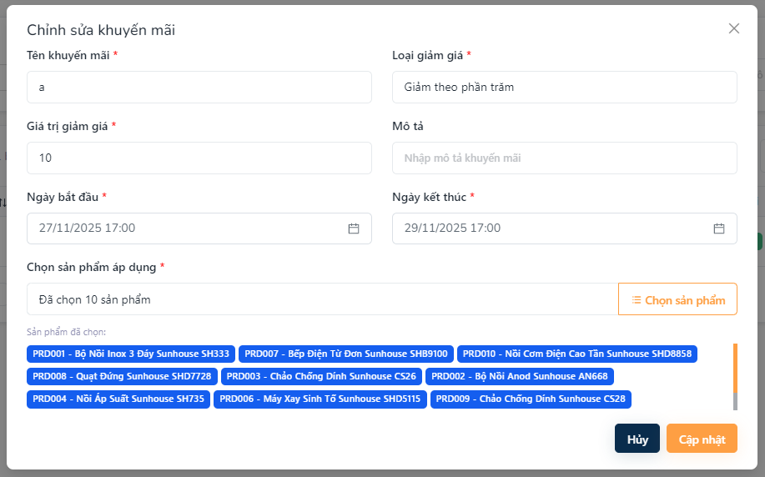
Figure 3.11.4. Edit Promotion
Step 1: Update promotion information
- Tên khuyến mãi: Field displaying the current promotion name. Editable to update the title.
- Loại giảm giá: Dropdown showing the current discount type (e.g., %, fixed amount). Can be changed if needed.
- Giá trị giảm giá: Field showing the existing discount amount. Editable to adjust the value.
- Ngày bắt đầu: Field pre-filled with the current start date. Can be edited if the promotion schedule changes.
- Ngày kết thúc: Field showing the current end date. Editable to extend or shorten the promotion duration.
- Mô tả: Field displaying the existing description or notes. Users may update or add additional details.
Step 2: Select Applicable Products
- View or update the list of products linked to this promotion.
- Users may add or remove products depending on the updated promotion scope.
Step 3: Complete Promotion Update
- Click “Cập nhật” to save all changes and update the promotion in the system.
- Click “Hủy” to cancel the update process and return to the previous screen without saving.

3.11.5 Delete promotion
- Description: This screen allows the user to delete an existing promotion from the system.
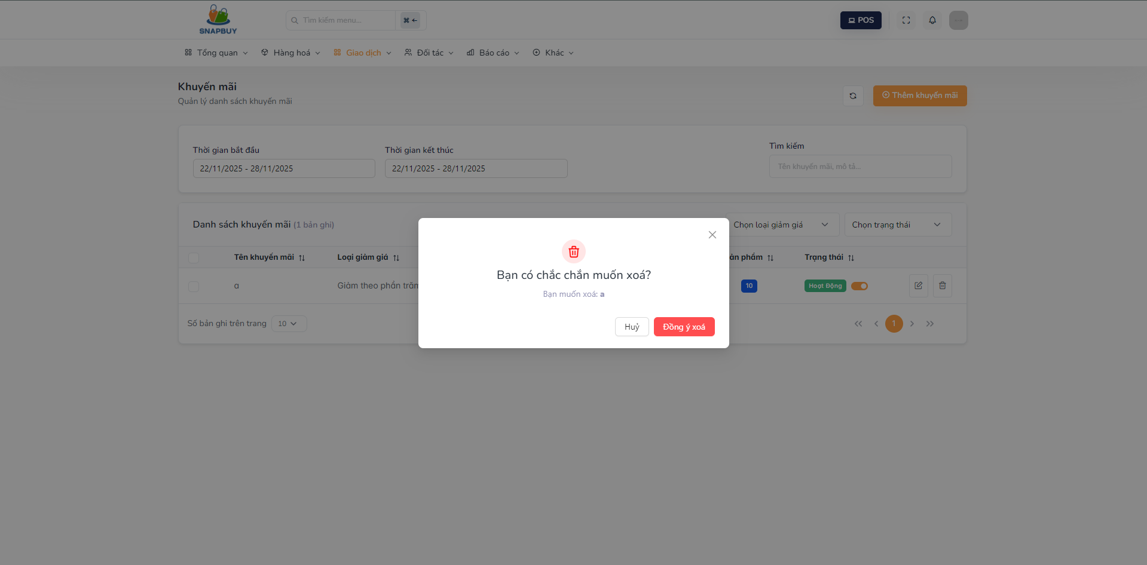
Figure 3.11.5. Delete Promotion
Step 1: Confirm deletion
- The system displays a confirmation message asking whether you want to delete the selected promotion.
Step 2: Complete promotion deletion
- Click “Đồng ý xóa” to permanently remove the promotion from the system.
- Click “Hủy” to cancel the deletion process and close the form without making any changes.

3.12 Product price

3.12.1 Product price list screen
- Description: This screen allows the user to view all product prices, search for specific products, and update selling or cost prices.
Step 1: When accessing the Product Price List screen, the system displays all products along with their pricing information:
- Tên sản phẩm: Displays the product name.
- Giá bán: Shows the current selling price of the product.
- Giá nhập: Shows the current purchase (cost) price of the product.
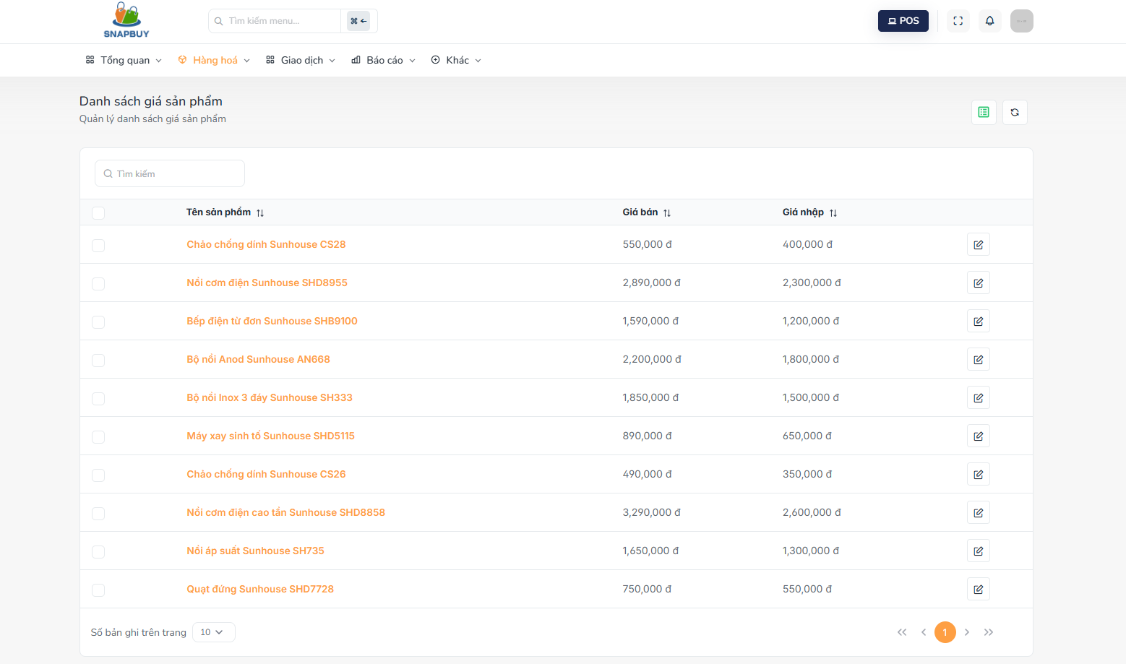
Figure 3.12.1. Product price list
Step 2: If user want to search product price
- Use the search field to find products by name or related keywords.
- The system filters and displays matching products automatically.
Step 3: If user want to edit product price
- Click the Pen icon next to the product whose price you want to update.
- The system opens the Edit Product Price screen.

3.12.2 Edit product price screen
- Description: This screen allows the user to update the selling and cost price of a selected product.
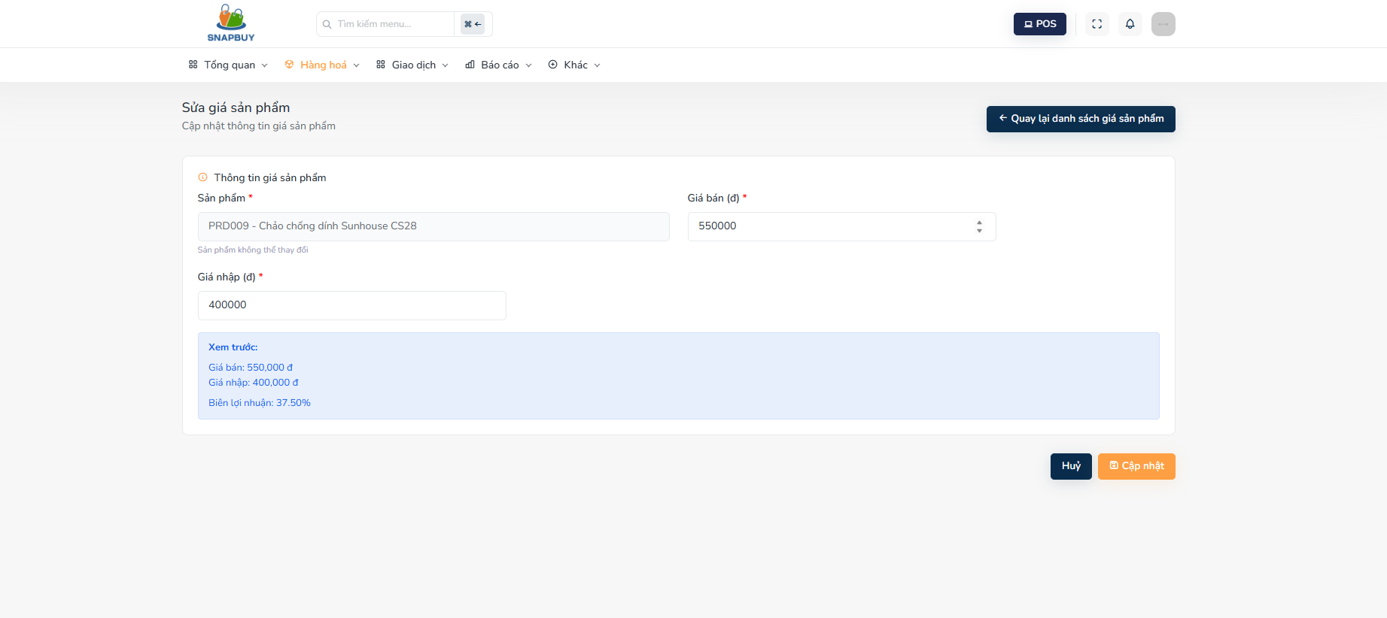
Figure 3.12.2 Edit Product Price
Step 1: Review Product Information
- Sản phẩm: Displays the product name and identifies which product’s price is being updated.
- This field is read-only and cannot be modified.
Step 2: Update Product Pricing
- Giá bán: Enter the new selling price or update the existing value.
- Giá nhập: Enter the new cost price or update the existing value.
- Both fields must follow the system’s price format rules (numeric values only).
Step 3: Save or Cancel
- Click “Cập nhật” to save all pricing changes for the selected product.
- Click “Hủy” to discard any changes and close the form without saving.
Step 4: Return to List
- Click “Quay lại danh sách giá sản phẩm” to navigate back to the Product Price List screen.

3.13 Report Management

3.13.1 Revenue Report
- Description: This screen allows the user to analyze business performance by viewing revenue, number of orders, average order value, and product sales based on a selected reporting period. Users can filter data, view charts, and review detailed product sales to support data-driven decision-making.

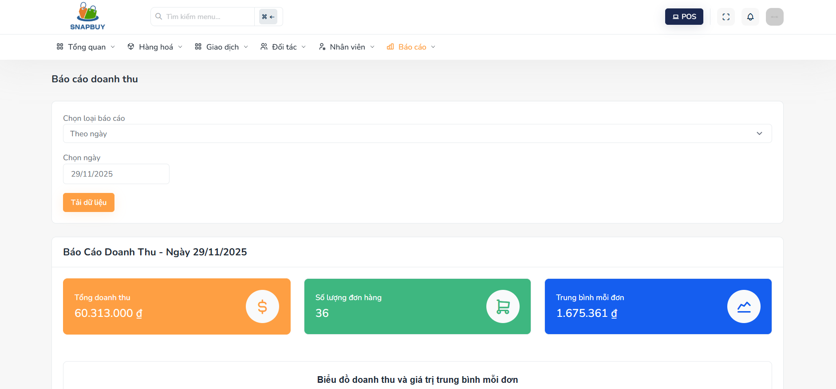
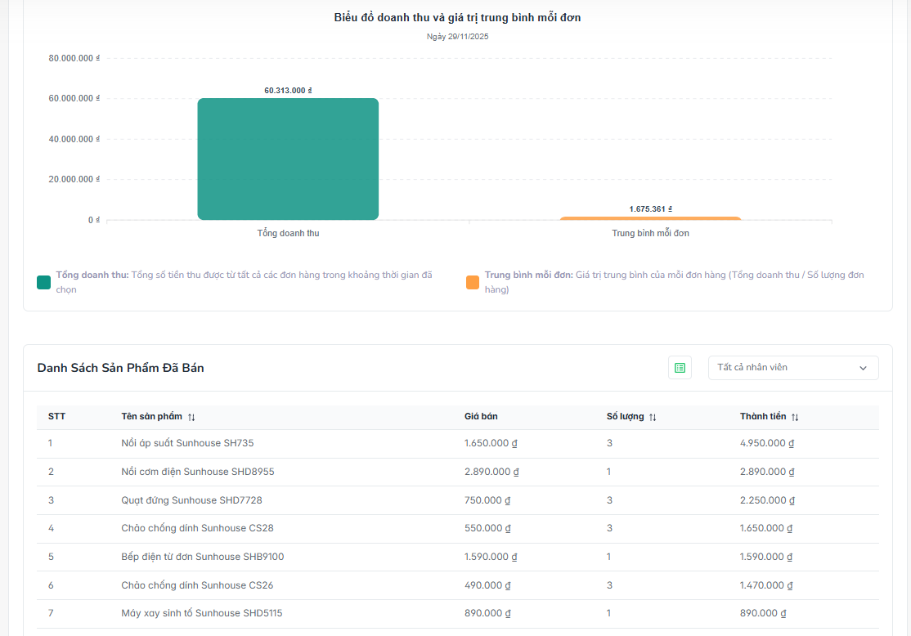
Figure 3.13.1 Revenue report
Step 1: Select report criteria
- Chọn loại báo cáo: Use the dropdown to select the type of revenue report you want to generate (e.g., Theo ngày, Theo tháng, Theo khoảng thời gian).
- Chọn ngày: Use the date picker to choose the specific date for the revenue report.
- Depending on the selected report type, this may represent: A single day ,A specific month, A range for aggregated reporting
- Tải dữ liệu: Click this button to load the revenue report based on the selected filters.
Step 2: View Revenue Summary Metrics
- After loading the data, the system displays three key performance indicators:
  - Tổng doanh thu: Total revenue generated within the selected period.
  - Số lượng đơn hàng: Total number of orders placed during the selected time.
  - Trung bình mỗi đơn: Average order value calculated as: Tổng doanh thu / Số lượng đơn hàng
- These metrics provide a quick overview of business performance for the chosen date or period.
Step 3: Analyze Revenue Charts
- The system provides interactive visual charts for deeper insight:
  - Biểu đồ doanh thu: A bar or line chart visualizing the total revenue for the selected period.
  - Biểu đồ giá trị trung bình mỗi đơn: A chart showing average order value, helping users evaluate customer spending behavior.
- These visuals support trend analysis and revenue comparisons.
Step 4: Review Sold Product Details
- Below the charts, a detailed table displays individual product sales:
  - STT: Index number of each product.
  - Tên sản phẩm: Product name.
  - Giá bán: Selling price of the product.
  - Số lượng: Number of units sold.
  - Thành tiền: Total revenue for each product (Giá bán × Số lượng).
- This list helps identify top-selling products and revenue contributions.
Step 5: Filter by Staff (Optional)
- Tất cả nhân viên: Dropdown filter allowing users to view revenue results for: All staff,A specific salesperson
- This feature supports performance evaluation and staff-specific reporting.

3.13.2 Product Report
- Description: This screen allows the user to analyze detailed product sales performance for a selected date or reporting period. Users can filter data, view key product sales metrics, and review a structured list of all sold products to support inventory planning and business decisions.

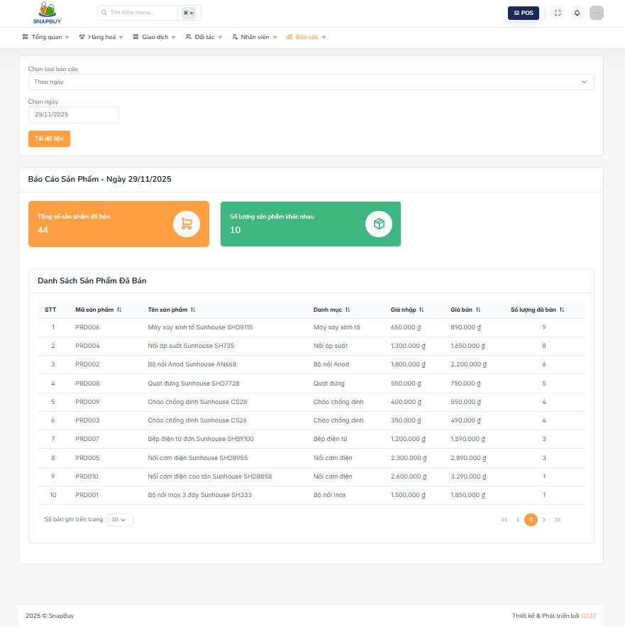
Figure 3.13.2 Product report
Step 1: Select Report Criteria
- Chọn loại báo cáo:Use the dropdown menu to select the type of product report
- Chọn ngày: Use the date picker to select the specific date for generating the report.
- Depending on the chosen report type, this may represent a day or an entire reporting period.
- Tải dữ liệu: Click this button to load and display product sales data based on the selected filters.
Step 2: View Summary Product Sales Metrics
- After the data loads, the system displays key indicators:
- Tổng số sản phẩm đã bán: Total quantity of all products sold during the selected period.
- Số lượng sản phẩm khác nhau: Total number of unique product types sold.
- This helps identify product variety and demand distribution.
- These summary figures provide a quick overview of product performance.
Step 3: Review Sold Product List
- A detailed table lists all products sold within the selected period, including:
- STT: Index number in the list.
- Mã sản phẩm: The product code used for identification.
- Tên sản phẩm: The name of the sold product.
- Danh mục: The category the product belongs to.
- Giá nhập: Cost price (purchase price) of the product.
- Giá bán: Selling price of the product.
- Số lượng đã bán: Number of units sold during the selected timeframe.

3.13.3 Customer Report
- Description: This screen allows the user to view and analyze customer purchasing behavior for a selected date or reporting period. It helps businesses understand how many customers purchased products, how many items were bought, and detailed purchase information per customer. This supports customer management, marketing strategies, and sales performance analysis.

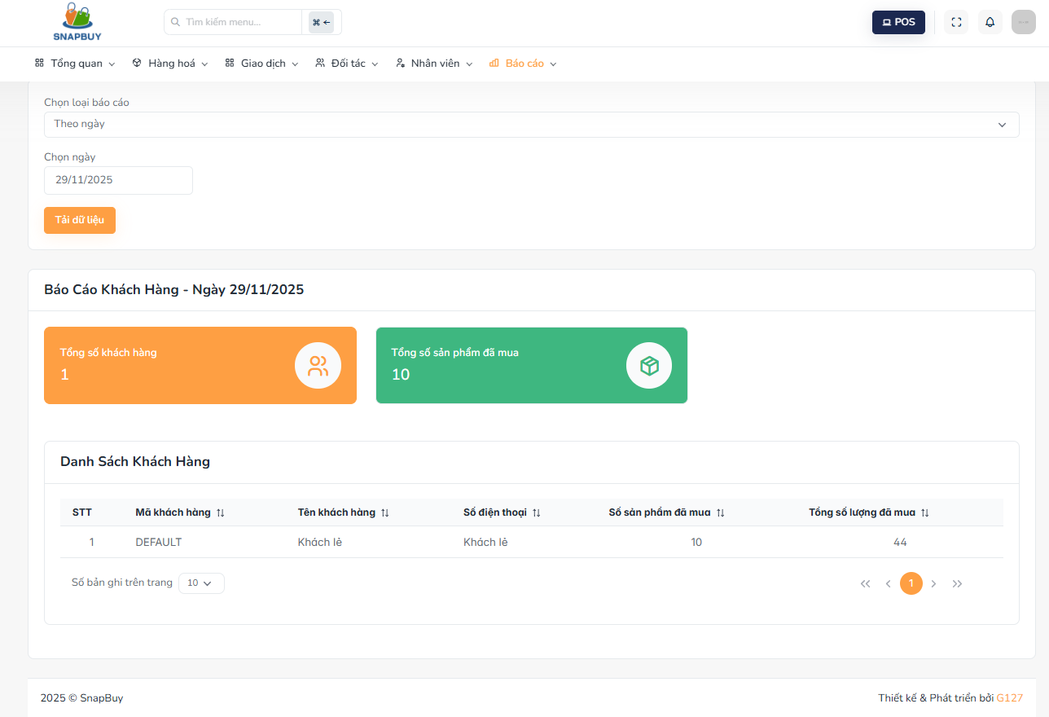
Figure 3.13.3 Customer report
Step 1: Select Report Criteria
- Chọn loại báo cáo:Use the dropdown to select the type of report
- Chọn ngày: Use the calendar date picker to choose the date or period for generating the customer report.
- Tải dữ liệu: Click this button to load customer purchasing data based on the selected report type and date.
Step 2: View Customer Summary Metrics
- After loading data, the system displays key customer activity indicators:
- Tổng số khách hàng: Shows the number of customers who made at least one purchase during the selected period.
- Tổng số sản phẩm đã mua: Displays the total number of products purchased by all customers combined.
- These metrics help assess customer engagement and buying volume.
Step 3: Review Customer Purchase Details
- Below the summary, the system displays a detailed customer list:
- STT: Index number of each customer in the report.
- Mã khách hàng: The unique identifier assigned to each customer.
- Tên khách hàng: Customer’s full name.
- Số điện thoại: Customer’s contact number.
- Số sản phẩm đã mua: Number of different product items the customer purchased.
- Tổng số lượng đã mua: Total quantity of all products purchased by the customer.

3.13.4 Supplier Report
- Description: This screen allows the user to view and analyze purchase and import performance from suppliers over a selected date or reporting period. It provides detailed insights into spending, product quantity, and supplier contributions, supporting procurement management and supply chain decision-making.
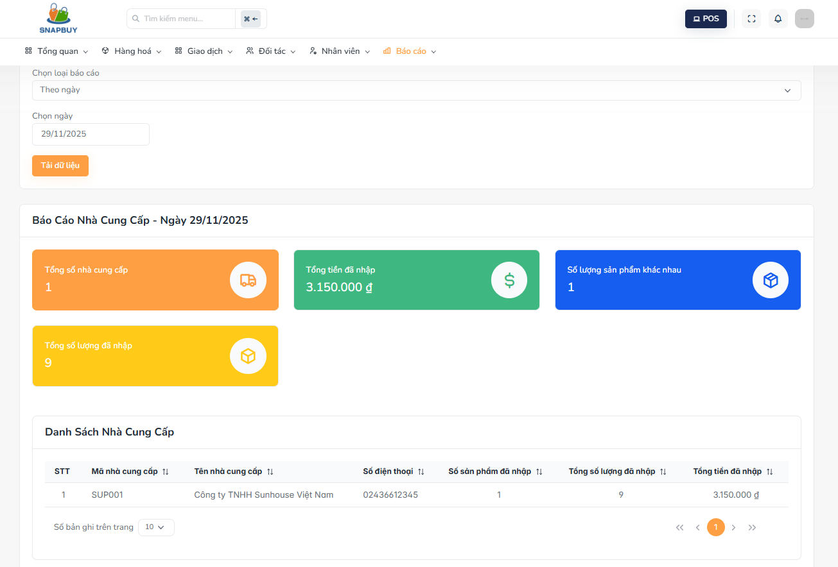
Figure 3.13.4 Supplier report
Step 1: Select Report Conditions
- Chọn loại báo cáo: Use the dropdown to choose the report type
- Chọn ngày: Use the date picker to select the reporting date or period.
- Tải dữ liệu: Click this button to load supplier data based on the selected filters.
Step 2: View Supplier Summary Metrics
- Once the data is loaded, the system displays key indicators:
- Tổng số nhà cung cấp: The total number of suppliers that provided goods within the selected period.
- Tổng tiền đã nhập: The total cost of all imported or purchased goods from suppliers.
- Số lượng sản phẩm khác nhau: The number of distinct product types purchased.
- Tổng số lượng đã nhập: The total quantity of products received from all suppliers.
- These metrics help users understand procurement volume, spending, and product diversity.
Step 3: Review Supplier Details Table
- The system displays a detailed list of suppliers with their purchase and import information:
- STT: Index number of each supplier in the list.
- Mã nhà cung cấp: Supplier’s unique identification code.
- Tên nhà cung cấp: The supplier’s official name.
- Số điện thoại: Contact phone number of the supplier.
- Số sản phẩm đã nhập: Number of different product types imported from this supplier.
- Tổng số lượng đã nhập: Total quantity of all products received from the supplier.
- Tổng tiền đã nhập: Total spending on goods purchased from the supplier during the selected period.

3.14 Workshift management

3.14.1 Workshift list screen
- Description: This screen allows the user to manage and monitor employee workshifts in real time. The system provides tools to open and close shifts, search employees, filter workshift history, and review detailed shift information. This ensures accurate time tracking and efficient employee shift management.
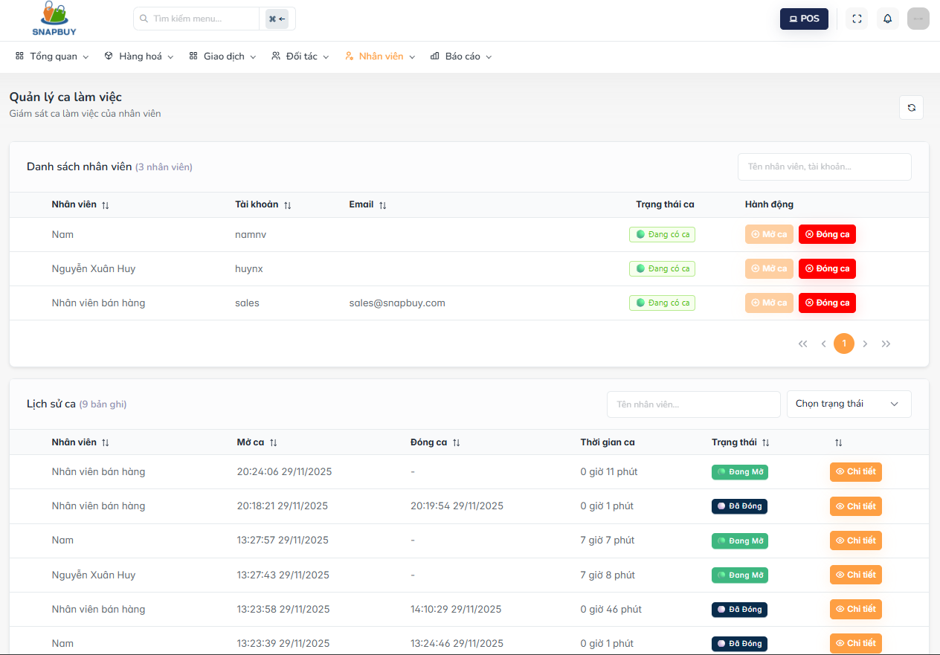
Figure 3.14.1 Workshift list screen
Step 1: View employee list and workshift status
- When accessing the Workshift Management screen, the system displays the employee list along with their current workshift information.
- Employee list:
  - The list includes the following fields:
  - Employee: The employee’s full name
  - Username: The employee’s system login username
  - Email: Employee’s email address
- Shift Status:
  - Shift Opened – The employee is currently in an active shift
  - Not Started – The employee has not begun a shift
- Actions:
  - Open Shift – Start a new workshift for the employee
  - Close Shift – End the current workshift for the employee
- Search Employee:
  - Use the search box to find an employee by name or username.
Step 2: Open or Close a Workshift
- 1. Open a Workshift
  - To start a workshift for an employee:
  - Locate the employee in the list
  - Click the Open Shift button
  - The system records:
  - Shift opening time
  - Shift status changes to Shift Opened
  - Note: An employee can only have one active shift at a time.
- 2. Close a Workshift
  - To end an active shift:
  - Select an employee with an active shift
  - Click Close Shift
  - The system updates:
  - Shift closing time
  - Total shift duration
  - Status changes to Closed
Step 3: View workshift history
- Below the employee list is the Workshift History section. This displays all previous and ongoing shifts.
- Each record includes:
  - Employee
  - Shift Start Time
  - Shift End Time
  - Shift Duration
- Status: Active ,Closed
- Detail: Opens a detailed view of the selected shift
- Filter by Shift Status:
  - Use the Status Filter to view: Active shifts, Closed shifts,All shifts, Search History
  - Enter an employee name to filter shifts related to that employee.
Step 4: View Workshift Details
- In the Workshift History section, click the Detail button
- The system displays comprehensive shift information, including:
  - Shift start time
  - Shift end time
  - Total working duration
  - Additional related details

3.14.2 Workshift detail screen
- Description: The Workshift Detail Screen provides a complete overview of an employee’s workshift, including cash denomination comparisons, shift revenue, order details, and any discrepancies between the start and end of the shift. This helps managers ensure accurate cash handling and validate shift performance.

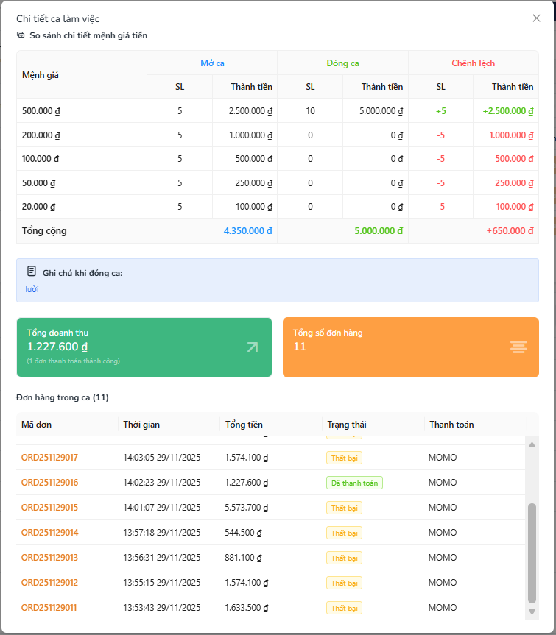
Figure 3.14.2 Workshift list screen
Step 1: When accessing the Workshift Detail screen, the system displays the cash denomination comparison
- The So sánh chi tiết mệnh giá tiền section shows differences in cash count between the beginning and end of the shift:
  - Mệnh giá: Displays the denomination value (e.g., 500.000₫, 200.000₫).
  - SL (Mở ca): Quantity of each denomination at shift opening.
  - Thành tiền (Mở ca): Total cash amount for each denomination at opening.
  - SL (Đóng ca): Quantity of each denomination at shift closing.
  - Thành tiền (Đóng ca): Total cash amount for each denomination at closing.
  - Chênh lệch: Difference between opening and closing amounts (surplus/shortage).
- This helps the user verify whether the closing cash matches the expected amount.
Step 2: Review closing notes and shift summary. Below the cash comparison, the system displays:
- Ghi chú khi đóng ca: Notes entered by the employee when closing the shift.
- Tổng doanh thu: Shows the total revenue generated from successful transactions during the shift.
- Tổng số đơn hàng: Shows the total number of orders created during the shift.
- These indicators help users evaluate overall shift performance.
Step 3: View the list of orders processed during the shift
- In the Đơn hàng trong ca section, the system shows all orders recorded in the shift:
  - Mã đơn: Displays the order ID.
  - Thời gian: Timestamp when the order was created.
  - Tổng tiền: Total amount of the order.
  - Trạng thái: Order status (e.g., Đã thanh toán, Thất bại).
  - Thanh toán: Payment method used (e.g., MOMO, Tiền mặt).
- This list helps users verify revenue details and order accuracy during the shift.

3.14.3 Open workshift screen
- Description: This screen allows the user to open a new workshift for an employee by recording the initial cash amount and optionally entering detailed cash denominations for tracking purposes.
Step 1: View employee information
- When accessing the Open Workshift screen, the system displays:
- Nhân viên: Shows the name and email of the employee whose shift is being opened.
- This confirms that the correct employee is selected before proceeding.

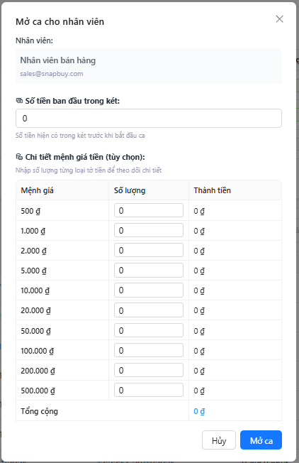
Figure 3.14.3 Open workshift list screen
Step 2: Enter initial cash amount
- Số tiền ban đầu trong két:
- Enter the total amount of cash currently in the register at the start of the shift.
- This is mandatory to ensure accurate tracking between opening and closing amounts.
- The system automatically uses this amount for shift reconciliation.
Step 3: (Optional) Enter detailed cash denominations
- If users want to track money more precisely, they may expand the section:
- Chi tiết mệnh giá tiền (tùy chọn): The user can input the number of bills/coins for each denomination:
- Mệnh giá: Displays each currency denomination (500đ, 1.000đ, 2.000đ, etc.).
- Số lượng: Enter how many units of each denomination are present.
- Thành tiền: The system automatically calculates the total amount per denomination.
- At the bottom, the system displays:
- Tổng cộng: The overall total amount based on all denominations entered.
- This step is optional but helps improve accuracy when comparing opening and closing cash.
Step 4: Complete opening the workshift
- Click Mở ca to officially start the shift.
- The system records all entered information and marks the employee as “Đang mở ca”.
- Click Hủy to cancel the process and close the form without saving any data.

3.14.4 Close workshift screen
- Description: This screen allows the user to open a new workshift for an employee by recording the initial cash amount and optionally entering detailed cash denominations for tracking purposes.
Step 1: Review employee information and closing notification. When opening the Close Workshift screen, the system displays:
- Nhân viên: Shows the employee’s name whose shift is being closed.
- A notification indicating that closing the shift will end the employee’s current work session.
- This helps confirm the correct employee before proceeding.

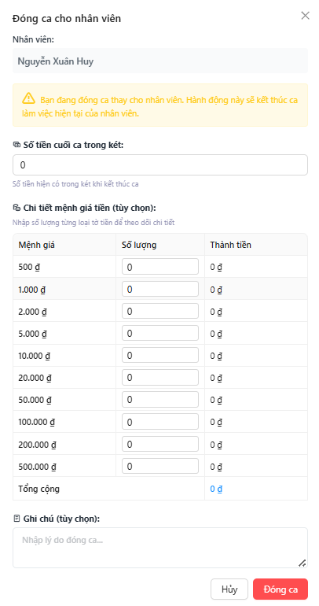
Figure 3.14.4 Close workshift list screen

Step 2: Enter final cash amount
- Số tiền cuối ca trong két: Enter the total amount of cash in the register at the end of the shift.
- This value is used to compare with the opening cash and calculate any discrepancies.
Step 3: (Optional) Enter detailed cash denominations. If needed, users may provide detailed denomination tracking:
- Chi tiết mệnh giá tiền (tùy chọn): Users can input the number of bills/coins for each denomination:
- Mệnh giá: Displays each denomination (500đ, 1.000đ, 2.000đ, etc.).
- Số lượng: Enter the number of units for each denomination.
- Thành tiền: Automatically calculates the total amount per denomination.
- The system summarizes all denominations and displays:
- Tổng cộng: Total amount based on entered denominations.
- This step is optional but improves accuracy when comparing cash balances.
Step 4: Add closing notes
- Ghi chú (tùy chọn): Users may enter a reason for closing the shift or any relevant notes.
- These notes will be displayed later in the Workshift Detail screen.
Step 5: Complete closing the workshift
- Click Đóng ca to finalize the shift closure.
- The system records all closing information and marks the shift as completed.
- Click Hủy to cancel the action and close the form without saving.

